Evaluation of Reading Schools 2022/23

September 2023

Contents

1. Introduction 1
2. Views on Reading Schools 7
3. Reading Schools Impact 26
4. Conclusions 41
Appendix 1: Examples of activity 43

Introduction

About this report

This is an evaluation of Scottish Book Trust’s Reading Schools programme during 2022/23. This year was the first year of the national roll out of Reading Schools.

This report explores learning around the delivery of each programme and the outcomes achieved through each programme.

About Reading Schools

Programme development
Reading Schools was first developed in 2019. It is an accreditation programme that aims to help schools build and sustain a reading culture. It is funded by the Scottish Government and delivered by Scottish Book Trust. There is no cost to schools for taking part.

Reading Schools was developed in partnership with Regional Improvement Collaboratives (RICs) for education. Each area is led by a working group which includes partners from the RIC, the local authority, the library service, Education Scotland and Scottish Book Trust.

19/20 | The programme began with a pilot, which was delivered in 39 schools during 2019/20. The pilot was delivered across the Forth Valley and West Lothian RIC, which includes Clackmannanshire, Stirling, Falkirk and West Lothian local authorities.

20/21 | The pilot programme was expanded. All schools in Forth Valley and West Lothian were invited to take part. In addition, 30 schools were selected by local authorities to participate across the Tayside RIC, which includes Angus, Dundee City and Perth and Kinross.

21/22 | Reading Schools was extended to include the West Partnership, which includes eight local authorities: East Dunbartonshire, East Renfrewshire, Glasgow City, Inverclyde, North Lanarkshire, Renfrewshire, South Lanarkshire, and West Dunbartonshire.

22/23 | The Reading Schools programme was rolled out across Scotland. It is now open to every school in Scotland.

Programme delivery
Through Reading Schools, schools can gain Core, Silver or Gold accreditation depending on their existing reading for pleasure culture. Schools can choose which level to start with.

The Reading Schools framework provides key areas that schools should consider, and each area is mapped to How Good Is Our School? 4. The Core key areas are:

Leadership of learning | - Reading leadership group involving learners  - Learners acting as role models  - Staff showing that they are readers  - Staff developing their knowledge around reading for pleasure and contemporary children’s literature

Leadership of change | - Whole-school action plan  - Comfortable spaces to read

Management of resources to promote equality | - Access to high-quality books in school and at libraries

Curriculum | - Regular opportunities to read for pleasure  - Interdisciplinary book projects

Learning, teaching and assessment | - Reading aloud to learners, sharing stories, providing access to books  - Staff meaningful conversations around books  - Creating learner networks  - Supporting learners to respond to what they are reading

Family learning | - Involving families in building the reading culture

Raising attainment and achieving | - Rewarding progress and celebrating achievements  - Tracking progress

The Silver and Gold frameworks build on the foundational work at Core level. Silver involves schools providing additional opportunities to broaden learners’ experiences such as engaging with authors, visiting libraries and bringing in other outside expertise. Gold further builds on this through schools sharing their enthusiasm and expertise with their communities. Schools can use a self-evaluation template and quiz to help them to decide which accreditation level best suits their school.

Schools can sign up to Reading Schools at the level they choose, and complete an action plan. The action plan is then sent to Scottish Book Trust for approval. Schools should then find out about the reading habits and views of learners and staff, put their plans into action and collect evidence including comments, quotes and photos.

Reading Schools is a rolling programme with no fixed deadlines. Scottish Book Trust aims to accept school action plans within five working days, and their evidence plan within 15 working days.

Scottish Book Trust offers resources, training and support, including professional development opportunities for staff. Schools signing up to the programme are supported to engage through workshops and professional learning sessions, delivered by Scottish Book Trust. The website includes recorded webinars on topics such as starting your Reading Schools journey, submitting evidence and key areas. Scottish Book Trust also offers drop-in sessions for schools who wish help or advice on their Reading Schools accreditation.

Programme participation
Accreditation through Reading Schools is available at Core, Silver and Gold level. As at mid-July 2023, 362 schools held Reading Schools accreditation. This is an increase of 129 since August 2022.

In July 2023, 487 schools were working towards their first accreditation. This is an increase from August 2022, when 370 were working towards accreditation. Scottish Book Trust updates participation and accreditation and a map is available online.

Evaluation method
This evaluation involved:

- Survey of Reading Schools participants – Scottish Book Trust issued a survey to all schools registered with Reading Schools – which focused on their experience of the programme. The responses to mid-July 2023 were used to inform this report – a total of 148 responses. A second survey was issued to schools which received accreditation – which focused on the impact of the programme. This received 124 responses.

- School interviews – Research Scotland spoke with 25 people from schools across Scotland about their participation in Reading Schools. This included primary schools, secondary schools and schools for pupils with additional support needs. It also included a mix of head teachers, deputy head teachers, principal teachers, class teachers and librarians.

- Wider feedback – Research Scotland spoke with partners and strategic stakeholders involved in the Reading Schools.

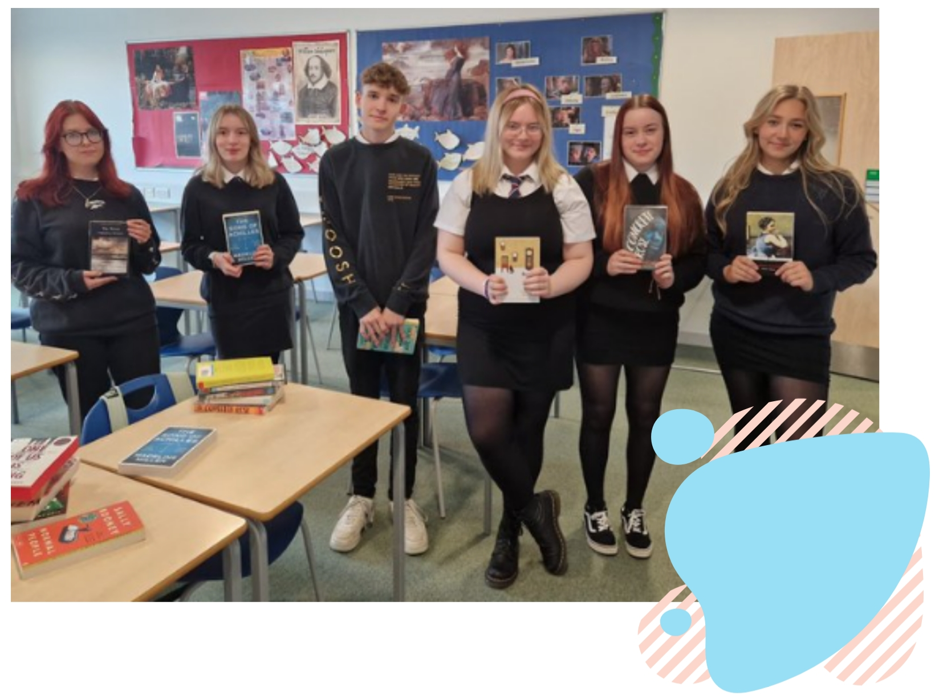

2. Views on Reading Schools

Introduction
This chapter explores the views of schools and wider stakeholders on the Reading Schools programme. It is based on a survey of participating schools with 148 responses, interviews with 25 people from 21 schools, and interviews with a small selection of wider stakeholders involved in the programme.

Through taking part in this evaluation, schools provided many examples of the types of activity they had developed through Reading Schools. Some of these examples are included in Appendix One.

Overall experience
Overall, schools responding to the survey rated the Reading Schools programme highly.

56%
38%
6%
0%
0%
Schools were asked to rate their experience out of five stars, and the average rating was 4.5.
“
It has brought reading to the front of the queue of the many initiatives that often require our time. It has shown the importance of encouraging every child as a reader, both at school and home.” Class teacher, primary

“
We feel that it is an engaging and supportive programme which offers excellent outcomes for schools. We love it!” Principal teacher, primary

Schools responding to the survey were asked to rate the extent to which they agreed with a range of statements. Overall, schools felt that the programme was flexible, inspiring and met the needs of their school.

97% felt that the Reading Schools programme was inspiring and exciting.

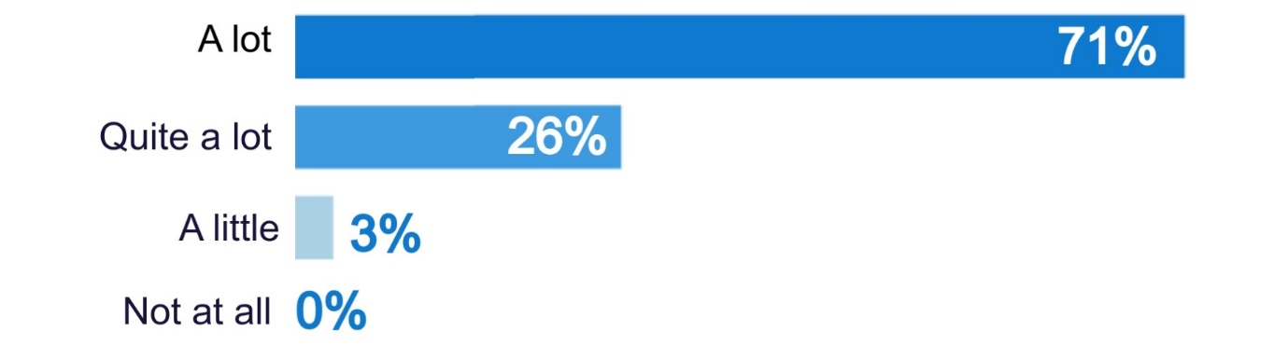

96% felt that the Reading Schools programme was flexible to the needs of their school.
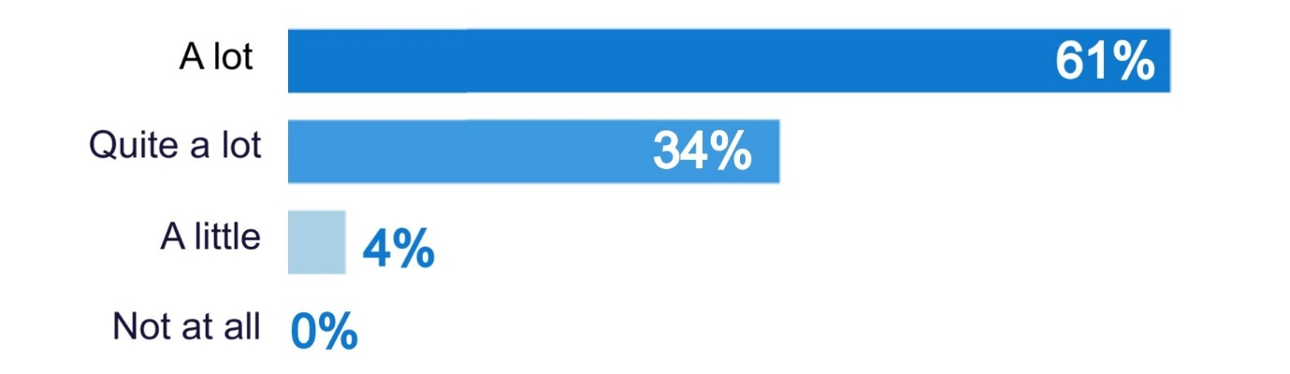

92% felt that Reading Schools was designed with the needs of their school in mind.
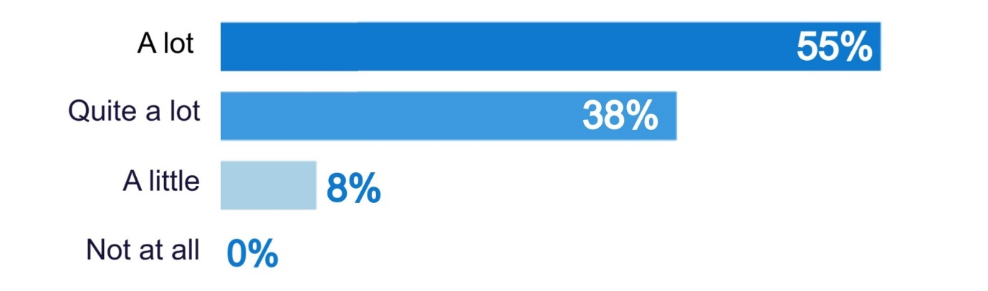
“
The Reading Schools programme has motivated and inspired teachers within my school. It's allowed us to focus and develop our skills developing a positive reading culture.” Principal teacher, primary

School staff involved in interviews emphasised that they highly valued the Reading Schools programme.

“
I think Reading Schools is very accessible, supportive
and easy to use.” Principal teacher, primary

“
The context of the programme is great. The process
of self-evaluation, then the action plan and the putting in
of evidence is all great.” Deputy headteacher, primary

“
I couldn’t recommend Reading Schools to other schools more highly. I think it’s a fantastic project and something that is really meaningful and can make a real difference to learners, no matter where they are in their reading journey.” Class teacher, primary

What works well
Overall, school staff responding to the survey and involved in in-depth interviews were very positive about the Reading Schools programme. School staff said Reading Schools worked well because it:

- provides a focus, direction and clear requirements
- is flexible and adaptable
- provides recognition for work to promote reading
- provides new ideas and is well supported by knowledgeable and helpful staff.

Focus, direction and clarity
From the survey, schools indicated that the most useful aspects of the programme were the self-evaluation and action plan, collaboration with others across the school, accreditation and mapping the framework to HGIOS4.

99% found the process of self-evaluation and action plan useful.
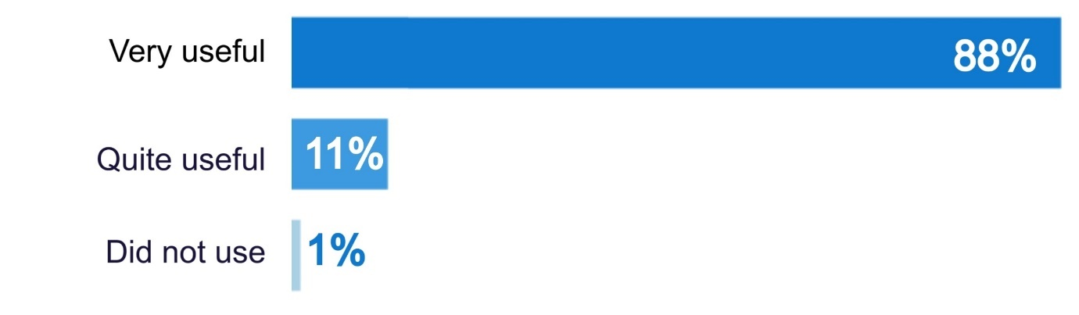

96% found the collaboration with others across the school useful.
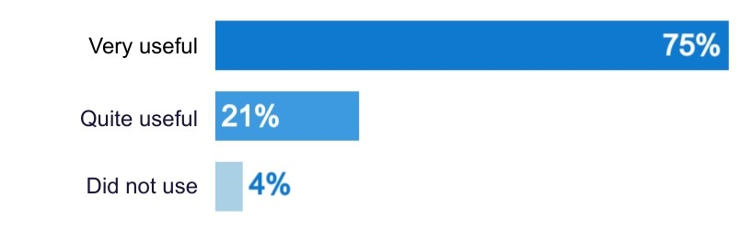

94% found the framework mapped to How Good Is Our School 4 useful.
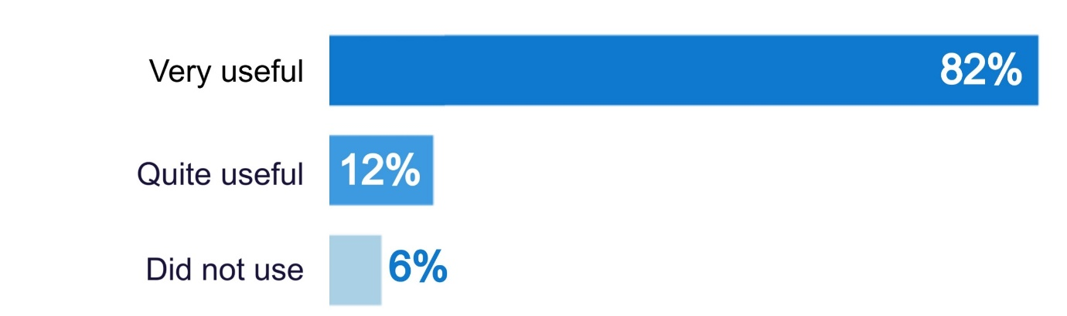

94% found the status accreditation provides useful.
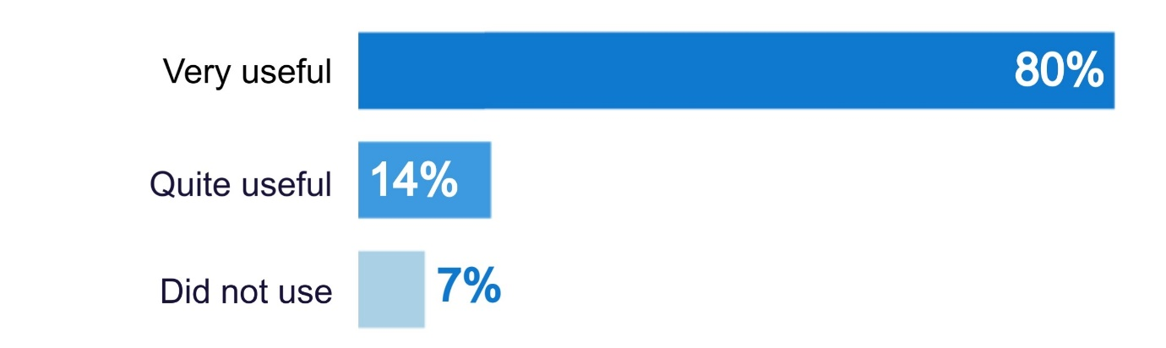
Schools felt that the Reading Schools programme was well structured, clear and linked well to school priorities and School Improvement Plans. Schools felt that it was easy to follow, and the structure of the action plan was straightforward and flexible. Some schools liked that they could use Reading Schools to inform school action plans around reading for pleasure.

“
We love the electronic action plan and evidence plan. It is so easy and clear what to do. We also really appreciated that we could build our action plan to suit our specific setting and circumstances.” Class teacher, secondary

“
Reading Schools is really closely aligned with How Good Is Our School. It’s broken down into leadership for learning, change, focus, assessment, and family and community, so from our point of view it’s great for monitoring progress... There’s that clear pathway through to school improvement planning.” Headteacher, primary

A few schools said that when they got involved in Reading Schools, they were struck by how much they were already doing around reading, and felt that the framework felt immediately relevant and achievable. Stakeholders also felt the programme was well designed in that schools can build on the work they are already doing.

“
Reading Schools recognises the work staff and pupils do already and challenges us to improve.” Class teacher, primary

“
It really did tie in with what we were doing in the school already not only in literacy but across the whole curriculum.”
Depute headteacher, primary

Schools liked the self-evaluation element, and felt that it helped them to continue to improve, understand what they need to develop, and critically evaluate their approach. Importantly, this self-evaluation was seen as helping to persuade others in the school, including senior staff, that reading for pleasure is important.

“
In Reading Schools there are clear outcomes and guidance. There has to be a sustainable element to what we do. Reading Schools gives you a clear pathway to accreditation, it lets you record your journey as a school. It’s not about getting the certificate for us, it’s about the change in our practice.” Headteacher, primary

Stakeholders agreed that the programme was very well structured, which was important for busy schools with multiple priorities. Stakeholders felt that Reading Schools had been well researched and planned, and feels accessible to schools from a wide range of backgrounds.

“
It’s incredibly user-friendly and the support you get from the Scottish Book Trust is brilliant.” Stakeholder

“
Reading Schools is brilliant. It connects clearly with HGIOS… It provides practical and professional learning… It’s well designed for schools and well structured for getting the message out.” Stakeholder

Adaptable and flexible
School staff emphasised that the programme was adaptable and flexible. Many highlighted that there was a range of options and ideas, different ways to meet outcomes, and different pathways and journeys through Reading Schools to suit individual schools. Schools felt that this meant the programme fitted well with the needs of each school, and the interests and talents of the team. An important part of this flexibility was having no deadlines, which meant that the journey could adapt as other issues emerged such as staffing challenges or other priorities.

“
I like the flexibility and ability to evidence as we go along.”
Class teacher, primary

Stakeholders also highlighted that Reading Schools was iterative and adapted along the way in response to feedback, which helped to strengthen and embed the programme.

Recognition
School staff valued that there was clear recognition through an award. Schools felt that this meant that the work of pupils, staff and librarians could be recognised, through a clear, external brand.

“
An award recognised by Scottish Book Trust
feels quite prestigious.” Teacher, additional support needs

“
It has been a positive in our school, an opportunity to
reflect and celebrate a lot of the good work we already do,
and has been a driver for change and improvement too.”
Librarian, secondary

Some also said that the programme motivated staff and pupils across the school, as they could see how they could get involved, work together as a whole-school, and have something tangible to aim for. Stakeholders agreed that Reading Schools created a ‘buzz’ with teachers, pupils and parents.

“
I've found it a great way to receive recognition for work
that already happens in school. It has been easier to get
other staff on board because there is something tangible
to aim for.” Librarian, secondary

New ideas and resources
Schools felt that Reading Schools information and resources available were useful and easy to find.

99% felt the information and resources on the website were useful.
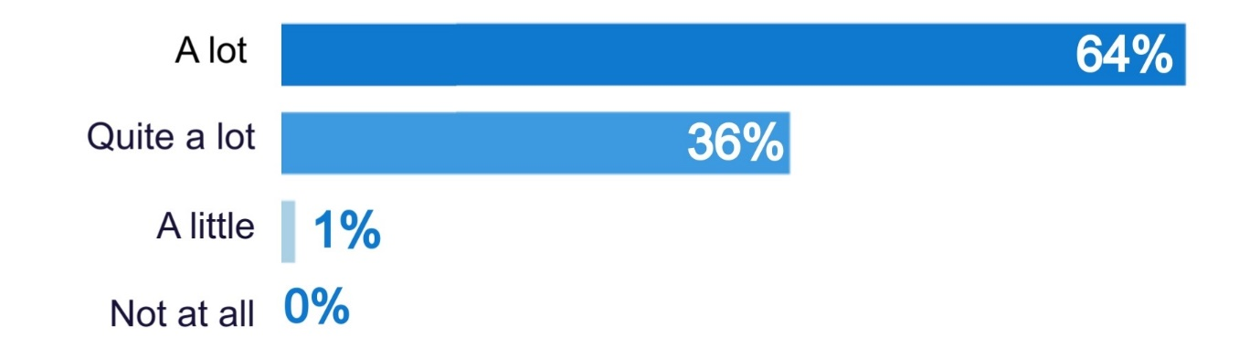

97% felt the Reading Schools dashboard was easy to use and understand.
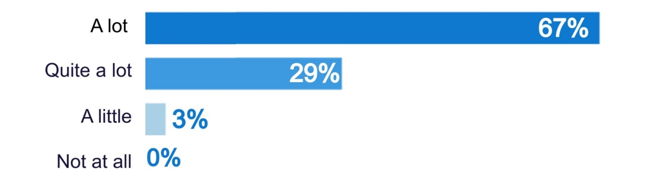

94% felt it was easy to find resources and information on the website.
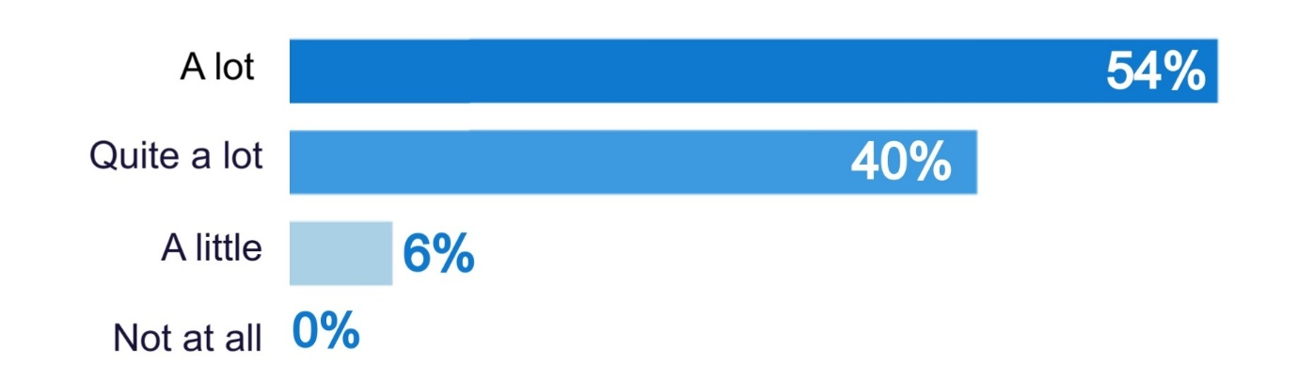

Survey respondents highlighted the resources and support available to introduce new approaches and ideas. Survey respondents highlighted that the website was full of good ideas, practical advice, links and resources, and was kept well up to date.

“
It’s a way to acknowledge what we are doing already but they also had really good resources and ideas. I would never have thought about some of the things otherwise.” Class teacher, primary

“
There are loads of great ideas on the website, and it's been a much easier sell to teachers since it's all been mapped to HGIOS key areas and levels.” Librarian, secondary

Support and learning
Schools were positive about the support provided by Scottish Book Trust.

95% felt that the information they received from SBT was useful.
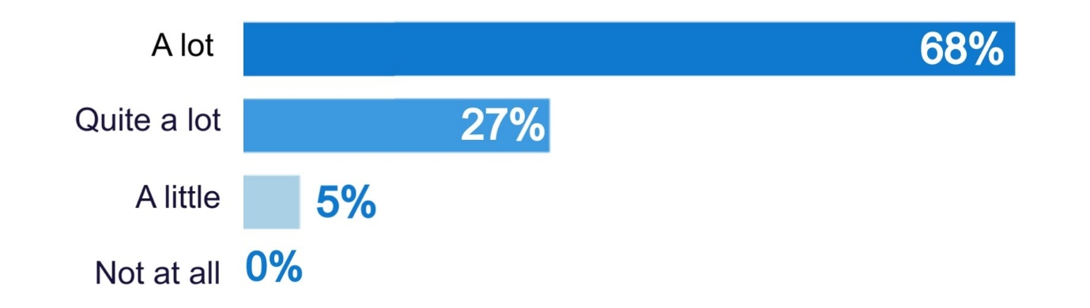

92% felt supported by knowledgeable and responsive staff at SBT.
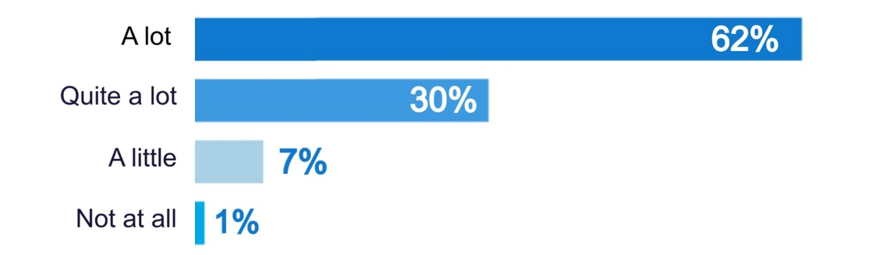

Schools felt that the support provided by Scottish Book Trust was responsive and supportive, and provided by knowledgeable staff who were available when needed.

“
Excellent support from SBT colleagues, brilliant online resources to take us step-by-step through the process.” Librarian, secondary

“
Clear process, excellent support available, regular CLPL sessions offered. I always feel there's someone at the end of an email who'll help me with any queries I have!” Librarian, secondary

The continuing professional learning and development was also seen as very useful.

96% found the CLPL around literacy and reading for pleasure useful.
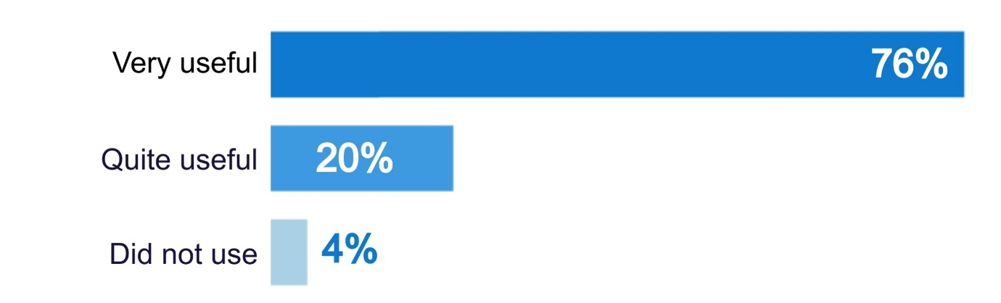

96% found the CLPL around participation in Reading Schools useful.
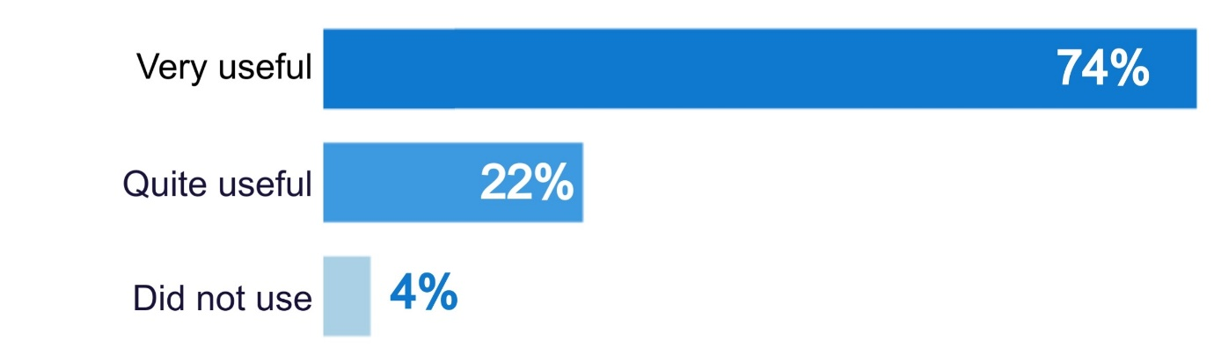

96% found the professional development inspiration for staff useful.
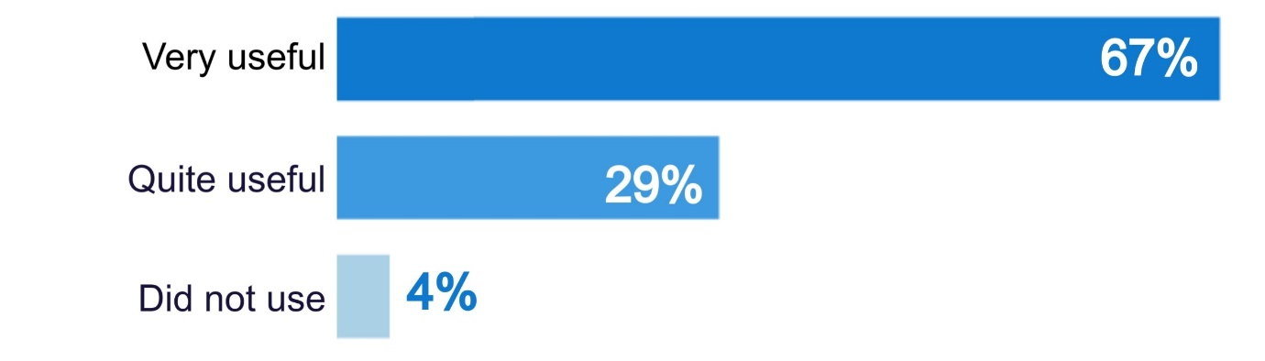

“
All CLPL opportunities attended have been very beneficial to our practice!” Headteacher/ deputy headteacher, primary

A few highlighted that it was useful that CLPL events were recorded, as often things come up unplanned in schools, and staff can then catch up at a later date.

Stakeholders indicated that a lot of support was provided through Reading Schools, and that there was a reputation for Scottish Book Trust providing high quality support through staff with expertise and dedication.

The survey respondents who did not rate the CLPL quite or very useful all indicated that they had not used this. One respondent commented that they hadn’t been able to find many CLPL opportunities on the website.

Deadlines
Survey respondents were specifically asked how they felt about there being no fixed deadlines for submission of their action plan and evidence. Almost all said that it was very helpful that there were no fixed deadlines. Respondents felt that there were already many deadlines for schools, and that having no deadline meant that:

- they could work at a pace which was right for their school
- activity could be more and less intensive to suit other pressures within the school – such as inspections, exams, busy pre-holiday periods, and other busy times
- the process was more enjoyable, and not just seen as another task
- activities and evidence were higher quality, as things could be done well rather than rushed.

“
This is incredibly helpful – at points in busy terms when prelims, folio and exams are looming it is great to know that the submissions can be made later on.” Class teacher, secondary

“
We feel strongly that this is a strength. There are so many pressures on schools and this helps us to be the best we can be.” Principal teacher, primary

Some felt that having a deadline could put people off, as there are so many other pressures in schools. Having no deadline was seen as helping the process feel more accessible and achievable.

“
Great! It means that it is an ongoing, rolling programme of improvement. A deadline can put people off if there are other time pressures.” Class teacher, primary

However, a small number of respondents felt that having a deadline could help keep things moving and found it helpful to set internal deadlines to make sure they progressed with the work. A few thought that there were deadlines in place for their action plan and evidence submission.

Areas for development
All of the schools that took part in this evaluation were very positive about their Reading Schools experience. Many highlighted that they enjoyed the programme and would change little about it. However, some potential areas for development were suggested including:

- Providing evidence – Many felt that finding the time to collate evidence was challenging, even for very committed teachers. Respondents emphasised how stretched schools are, and felt that this was too time intensive even for those who are “massive fans” of the Reading Schools programme. Many suggested reducing demand for evidence, and ensuring that there is no duplication or demand for very similar evidence.

A particular issue was raised by a few small schools, who said that the volume of evidence required could be tricky – for example providing a range of pupil quotes when there are only a small number of pupils.

“
The evidence collecting is really quite a long and arduous process. I feel that could be slimmed down.” Headteacher, primary

- Uploading and exporting evidence – Many felt that the portal to upload evidence could be challenging and frustrating. Schools would like to be able to upload zip files, more than one photo at a time and provide links to places where evidence is already collated. Some also felt that it would be nice if the evidence submitted for previous Reading School levels could be moved across and form the basis of the next application, for Silver or Gold level. A few said that because the form is online it is easy to forget what you’ve included in previous sections and some would like to be able to export, download and print off their uploaded evidence.

- Connections – Some survey respondents would like more opportunities to connect with other schools in their local authority area – or across Scotland –who are part of Reading Schools. The focus would be on sharing practice, ideas and achievements with other schools on the same journey. This could be via Teams, or a virtual community of Reading Schools leaders, to compare experiences and ideas. In responding to the survey, quite a large proportion (17%) said that this sense of community wasn’t something that had been part of their Reading Schools journey so far. A few would also like some more examples of action plans, evidence plans and more case studies of schools accredited at different levels. Some stakeholders suggested that there may be value in having champions or ambassadors for Reading Schools at local authority or cluster level, to advocate for the programme. Scottish Book Trust staff highlighted that this collaboration and networking was a key focus for 2023/24.

- Practical help – Some schools suggested ideas for further practical help including templates or crib sheets for ideas that could be easily transferred between schools. Some also would like to see up to date lists of comics, fiction and non-fiction books to support schools to build their collection (alongside wider funding support). A few small schools said it would be good to have more resources, advice and ideas for how small schools could achieve their Reading Schools journeys.

- Continuing professional learning and development – A few survey respondents and stakeholders suggested ideas for further CLPL – for example focusing on interdisciplinary learning (particularly at secondary school), parental engagement or meeting the needs of young people with additional support needs. A few said it would be useful to have a plan for the CLPL events for the year that could be easily sent to staff to sign-up and build into their schedules well in advance. A few people were not aware that CLPL sessions were recorded, and felt that this would be useful.

- Reducing paperwork – A few mentioned that they felt at first the paperwork around Reading Schools was resource intensive and may be off putting for schools and make it hard to involve staff and pupils more widely.

“
The Reading Schools programme seems a whole lot more work. It’s a lot more formal and there seems to be a lot more paperwork.” Class teacher, primary

A few suggested that an early visit from Scottish Book Trust at action planning stage might help – at school or local authority level. Stakeholders agreed that although the programme was well structured and user friendly, it could seem like a lot of work at the outset. However, some felt that if the process was made much easier or diluted, the change brought about would be reduced and the accreditation would be less meaningful.

- Simplifying the action plan – A few felt this could be more user friendly, be more fun and include a bit less detail. The quiz and self-evaluation to support schools to establish where to start was felt to help, and schools felt they could then approach their action plan in manageable steps.

- Secondary school context – A few mentioned that it was harder to develop a whole-school approach in secondary schools, with a wide range of other priorities and awards, and everyone working at – or above – full capacity. A few felt that it would be useful to have more recognition that it can be hard to get whole-school commitment at this level, and to adapt the programme, requirements and resources to suit the secondary school context. For example, a few said it would be nice to more clearly designate different parts of the action plan for primary or secondary school only. However, others felt that this was already clear. Scottish Book Trust staff indicated that working with secondary schools was a key priority for 2023/24, particularly in light of secondary school librarian roles being lost resulting in challenges around leadership for Reading Schools.

“
What I loved about it were the various different options. It was very clear what was required of us and how that translated into a secondary school setting.” Librarian, secondary school

- Rural school context – A few rural schools indicated particular challenges engaging with the wider community due to being in a rural and remote area with limited facilities (like libraries/ bookshops or community groups) and limited or no public transport networks. A few rural schools indicated that this meant that achieving some of the outcomes of Reading Schools were challenging, but that Scottish Book Trust was flexible and understanding of the differing context for schools.

Many of the comments were made in connection with the workloads and capacity within primary and secondary schools. Survey respondents and interviewees highlighted that 2022/23 had been a very pressured year, with post Covid recovery, school strikes, staff absences and staff vacancies. A few said that this meant it could be hard to get buy in across the school, and it could be hard to motivate teachers to be involved. A few also highlighted that their role was a non class teaching role, which gave them the time to drive Reading Schools, but that it would be hard to undertake the work involved if in a class teaching role.

“
It’s all about workload with teachers at the moment and workload is horrendous and getting worse. Unless I can get a principal teacher or DHT on board I just wouldn’t be able to spread it across the school.” Class teacher, primary

“
Hard to sustain engagement with teaching staff who are under increasing pressure.” Librarian, secondary

A few school staff also mentioned that they would like more celebration of their accreditation – but recognised that celebration activities may have been curtailed by the pandemic in recent years. Stakeholders also felt that celebratory events were important to recognise achievements and inspire other schools.

Scottish Book Trust staff indicated that there was a need for awareness raising and communications around Reading Schools to make sure the opportunity is available to as many schools as possible. This could include providing a softer entry and information point to Reading Schools on the website, and making sure schools know how to access early support through SBT. A few stakeholders suggested that there may be value in considering connections with contemporary issues in schools, such as climate change and children’s rights to encourage participation.

Future participation
All of the schools which took part in the survey and interviews said they would continue to participate in Reading Schools in the future. Survey respondents said that staff and pupils had really enjoyed the Reading Schools programme and that it was worthwhile and made a difference to their school. Schools could see the impact of their work through Reading Schools and wanted to continue to build on this.

“
It is a really useful programme which provides worthwhile, exciting and engaging ways to create a reading culture.”
Class teacher, primary

“
It has created a sense of community, enthusiasm and motivation for reading.” Principal teacher, primary

“
The programme is absolutely worthwhile and the whole school has benefited from it and found pleasure in reading.”
Class teacher, primary

Almost all said that they want to go on to gain higher awards. A few, particularly smaller schools, said they would need to investigate the resources required to progress to Silver or Gold before committing, due to pressures on staff.

“
We will continue to engage in the process and intend to work towards getting our Gold accreditation because our whole school community is so enthused by what we have done so far.” Principal teacher, primary

“
We are on the path to submit evidence for the Core award and are keen to keep going to achieve Gold.” Class teacher, primary

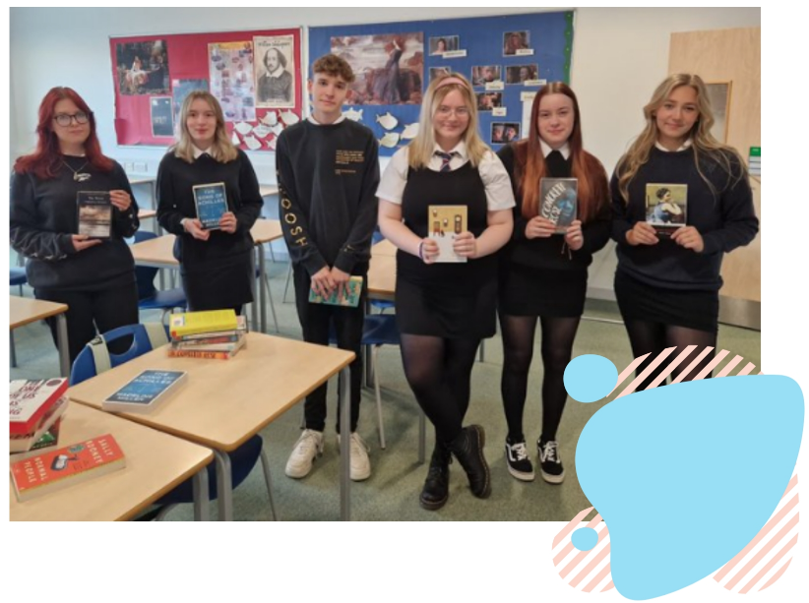
Stakeholders also indicated that encouraging uptake of Reading Schools was a priority for them, due to the value of the programme.

Example: South Ayrshire Reads
In South Ayrshire, there is a clear aim that between 2023 and 2026 all schools will have completed or started their Reading Schools journey. Schools will be supported to embed reading for enjoyment, and build a real lifelong love of reading, equipping pupils for life beyond school. Schools will take whatever approach suits them best, within Reading Schools, and there will be work to share experiences of Reading Schools between schools and with the wider community – for example through reading and gaming, cookery and sport community sessions. There will be a particular focus on Reading Schools activity around key transition stages between primary and secondary school. The programme will also involve links with the local university, which aims to become a reading university.
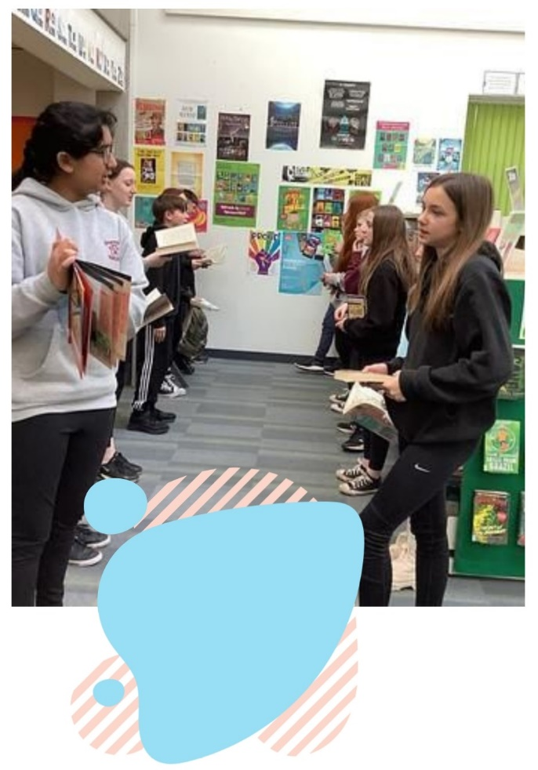

Reading Schools Impact

Introduction
This chapter explores the impact participation in Reading Schools had on schools during 2022/23. It is based on a survey of schools taking part in Reading Schools, which received 124 responses and interviews with a small number of schools participating in Reading Schools.

Impact on reading
Schools taking part in the survey and in-depth discussions were very positive about the impact of Reading Schools on pupils’ reading behaviours and experiences.

96% said pupils became confident in their reading choices.
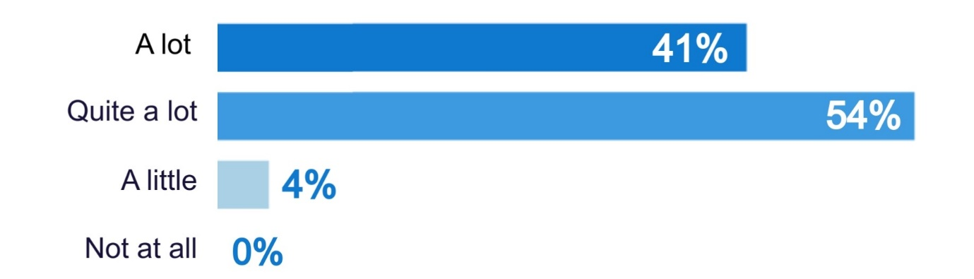

97% said pupils were able to choose and find books they enjoy.
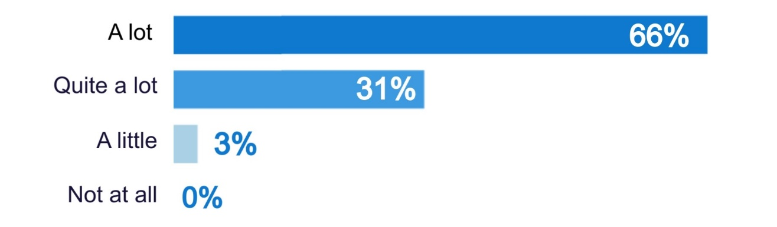

92% said pupils read regularly and widely.
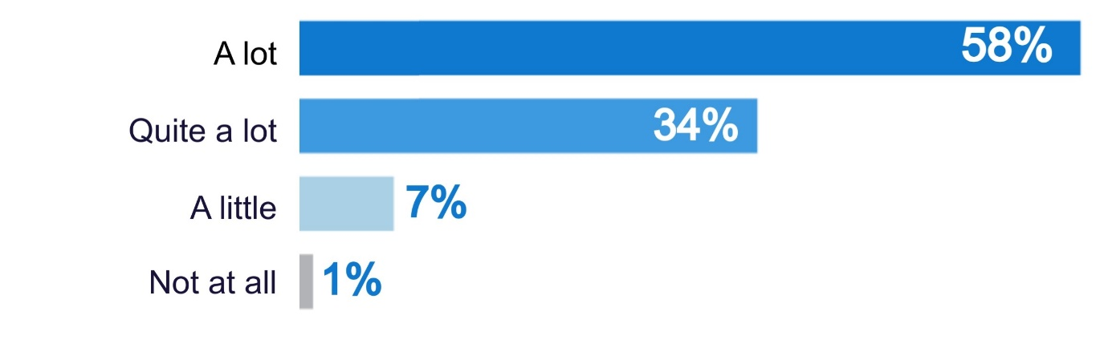

89% said pupils identify as ‘readers’.
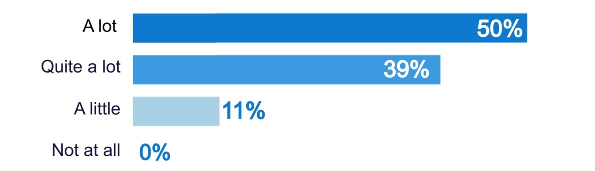

93% said pupils now enjoy reading.
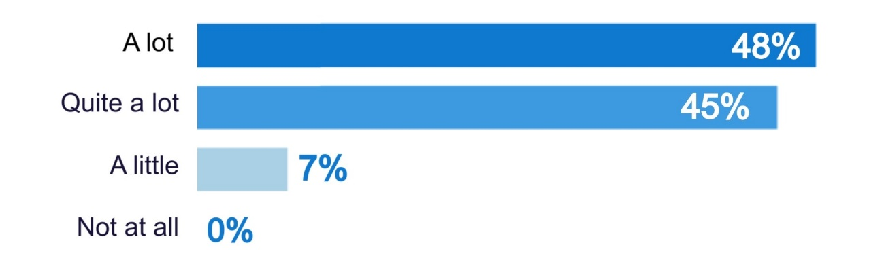

93% said pupils connect with others around reading.
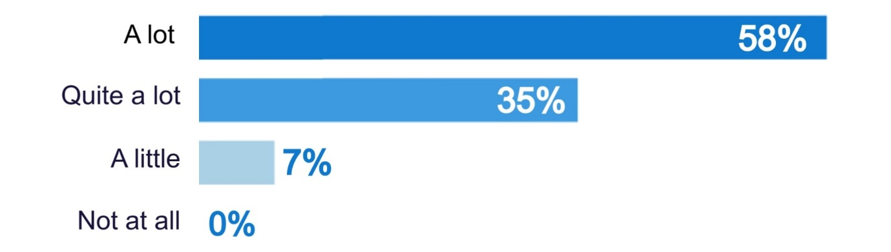

In discussion, schools said that the way pupils and staff talked about reading had changed, through taking part in Reading Schools. Many described it as having an enthusiasm, excitement and ‘buzz’ about reading. Key changes included pupils:

- seeing reading as fun, not a chore
- feeling comfortable talking about books
- feeling they can find a space to read when they want
- feeling happy reading lots of different types of books
- wanting to go to the library or read in class
- coming up with their own ideas about reading in school.

“
Now you walk in the class and it’s ‘Are we writing today?! Are we reading today?!” and you think ‘yes! We’ve got it!” Head teacher, primary

“
It’s changed the mindset for a lot of children and they now share a love of reading. That’s the project’s legacy. The impact will be long-term.” Principal teacher, primary

“
The children are just happy to read. It’s not just sitting at their desk now, we’ve got cushions, and they’re mixing across the ages too with older ones reading to younger pupils.” Depute headteacher, primary
Example: enjoying reading at school
“We’ve incorporated reading into our routines. Time reading excites everyone every day. After the lunchtime playground dramas, they want to come back in after breaks. They can read independently, in groups, listen to audio books. We prioritise comfy reading in the school, so we have loads of cushions and rugs. Children can lie on a cushion or turn their chair upside down and lean against it to read. Ultimately reading is a pleasure and should be a sociable activity. It’s lovely seeing them reading to each other.”

Survey respondents had noticed changes in the levels of reading for pleasure particularly among pupils who were not previously enthusiastic readers and socioeconomically disadvantaged pupils. Almost all (96%) noted some increase in the level of reading for pleasure among pupils who were not previously enthusiastic readers, with almost half (44%) noting a big increase.

Have you noticed any changes in the level of reading for pleasure among particular groups of pupils because of Reading Schools?

 | Big increase | Little increase | No impact | Decline | Not sure
Pupils who were not previously enthusiastic readers | 44% | 52% | 3% | - | 1%
Pupils with English as a second language | 18% | 50% | 10% | - | 22%
Socioeconomically disadvantaged pupils | 36% | 54% | 3% | - | 7%
Pupils with additional support needs | 23% | 71% | 1% | - | 5%

Survey respondents felt that the impact on girls and boys had been broadly the same, with no notable differences.

A few highlighted that the leadership and pupil voice aspect of the Reading Schools programme helped to engage reluctant readers, who felt valued, had a voice and sense of ownership, and then became more interested in reading.

“
Since we began our activities there has been a real buzz about reading in the school. This has improved the ethos within our school – in particular the ability for different pupils to mix, gain leadership skills and remove barriers to reading for pleasure.” Literacy champion, primary

Example: equality
One school worked with its Rights Ambassadors to choose books that focus on equality and diversity. A bilingual reading corner was also created, with QR code links to staff, pupils and parents reading books in a range of languages.

Example: equality
One secondary school got funding through Reading Schools to run a programme with families of pupils with English as an Additional Language. Pupils were gifted a book, some of which are dual language books. The school also ran a community café where families came in and shared food and talked about books. The school, supported by its S6 helpers, created ice breakers to talk about books parents enjoyed when they were younger and to talk about what they read at home.

Impact on learning
Schools responding to the survey felt that Reading Schools had impacted positively on learning and attainment. In particular, schools felt Reading Schools contributed to pupil wellbeing and creativity, and had a positive impact on pupil attainment and critical literacy.

87% felt that Reading Schools had contributed to wellbeing.
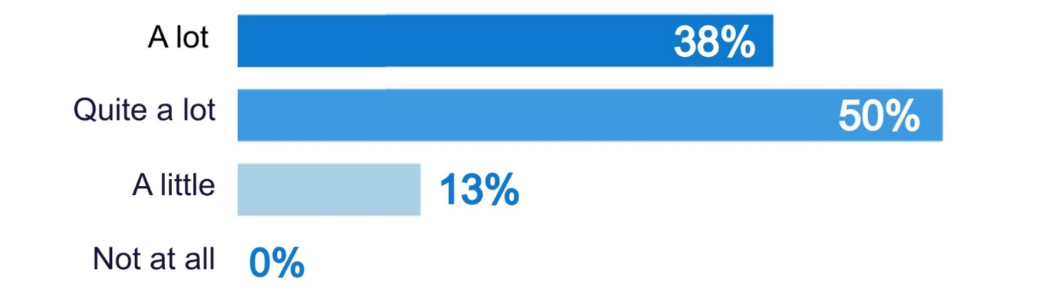

81% felt that Reading Schools had contributed to creativity.
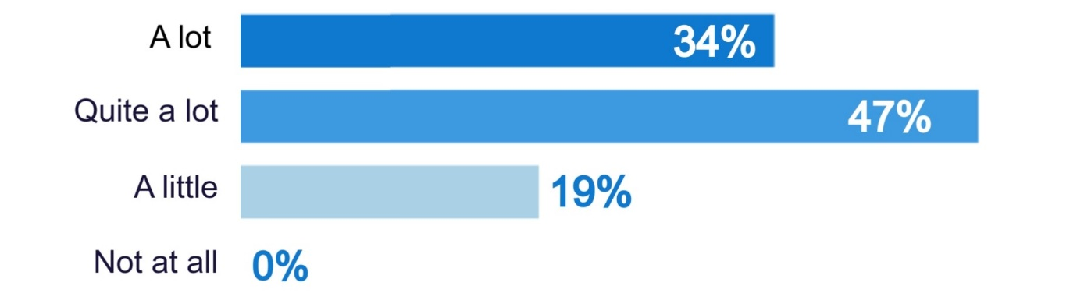

76% felt that Reading Schools had contributed to pupil attainment.
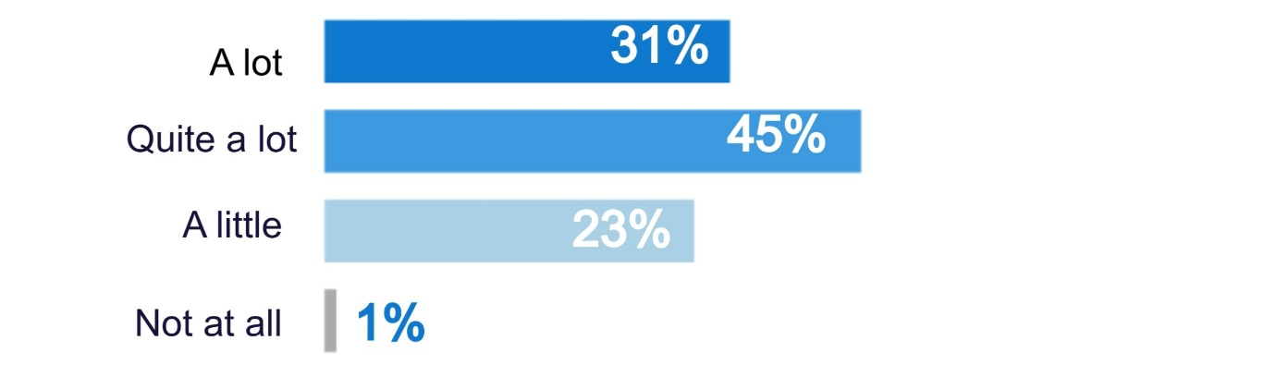
73% felt that Reading Schools had contributed to critical literacy.
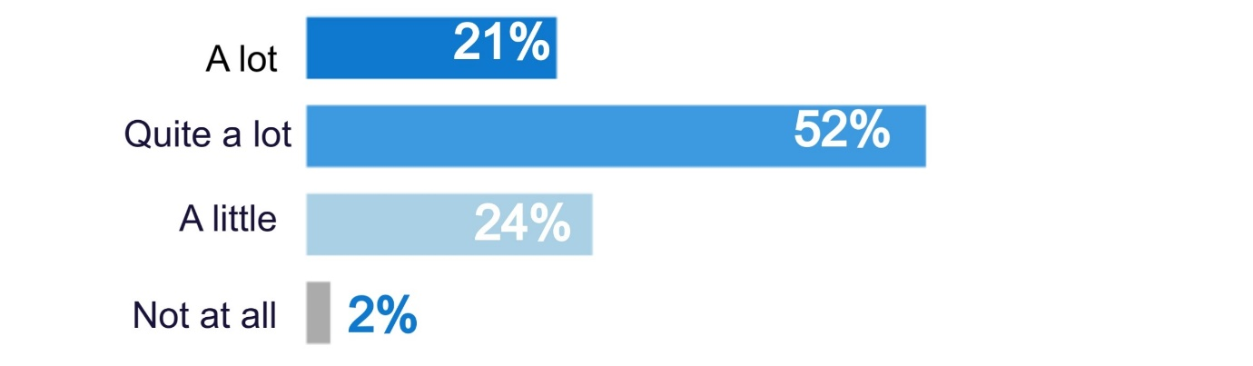

70% felt that Reading Schools had contributed to empathy.
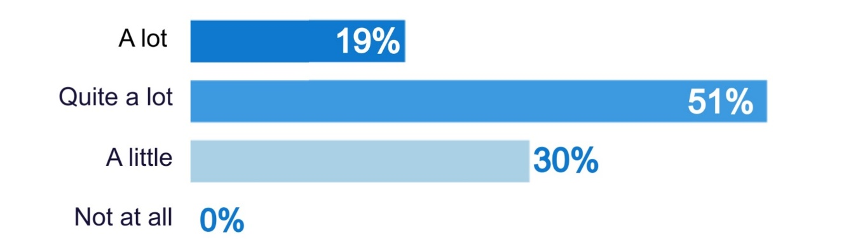

64% felt that Reading Schools had contributed to resilience.
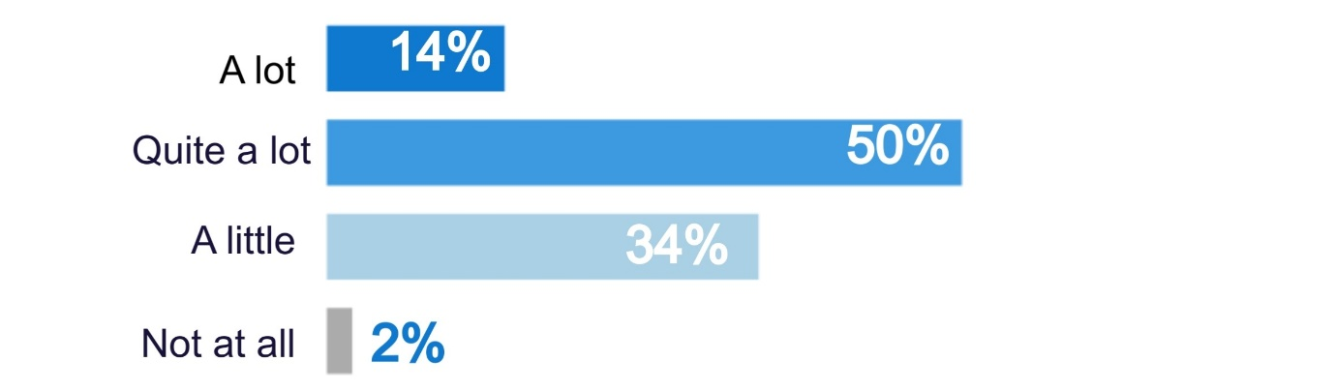

Schools talked in particular about the impact of reading for pleasure in supporting positive wellbeing. Schools highlighted that reading for pleasure provided a calm and peaceful environment for children to regulate their emotions, learn how to express themselves and have a voice to share their passions. Some were using reading as calm time during or shortly after breaks and lunch, to help pupils to manage their emotions.

“
There’s more time for peace and calm within the class. There’s a real emotional impact of reading. Some kids come in from an environment that can be quite chaotic and stressful, so knowing that there’s one lesson a week where they can sit and be quiet in a safe space. The emotional impact of that is so valuable.” Secondary class teacher, ASN school

“
It’s a nice calming way for the children to come in. It’s a calm start for children going into classroom. And children are now using reading themselves to self-regulate. We have cards if children need to move or want some quiet time, so they can show the card if they need and will take themselves to library.” Principal teacher, primary

Some schools highlighted that having a more diverse selection of books available to pupils helped them to understand different experiences, develop more empathy with people from different walks of life and explore their own and other people’s perspectives. A few also said that through reading alongside pupils, teachers could begin other conversations without the pressure of eye contact, and could learn about pupils through the choice of book they make.

Example: reading and nurture
In one primary school, everyone stops what they are doing at 3pm and reads until 3.15 when school ends. Senior pupils act as reading managers and go round to the classes and remind people to stop what they are doing and read, and encourage teachers to get their book out too. Everybody stops at this time – pupils, the headteacher, teachers and office staff.
“We spend a lot of time trying to create moments to talk, but this creates moments of quiet. If you walk around this school at 3pm it’s a quiet, calm, nurturing time. And that makes it a good transition time.” Headteacher, primary

Example: health and wellbeing
One secondary school developed a Reading for Empathy project. Pupils received training with The Empathy Lab and S2 pupils volunteer as empathy champions. The pupils are holding Reading for Empathy sessions across S1 to S3, promoting tolerance, understanding and kindness. The school also has a collection of Reading for Empathy books to support this work.

Most schools felt that the Reading Schools programme:

- Helped to recognise and reward pupil’s achievements – 94% said that it helped a lot or quite a lot, with 5% saying it helped a little.
- Contributed to reducing or closing the poverty related attainment gap – 55% said it helped a lot or quite a lot, with 38% saying it helped a little.

Some schools said that they had seen improvements in attainment, which could be linked to reading for pleasure through Reading Schools. Schools pointed to improvements in reading, vocabulary, writing, punctuation, critical thinking, emotional literacy, leadership and ownership of learning.

A few said that as reading skills and confidence improved and this transferred across to other areas of the curriculum.

“
We have seen an improvement in our reading attainment across the school and pupils are enjoying reading and choosing to read.” Class teacher, primary

“
Our Reading attainment data has increased this year which could be as a result of the reading for pleasure opportunities that we provide.” Class teacher, primary

In discussion, a few schools said they had seen noticeable improvements in attainment which they felt could be directly attributed to Reading Schools.

Example: reading levels
One school saw a clear change in attainment within a year of their Reading Schools journey. Previously, primary 7s were sitting at 54% being on track for reading at their level, and within a year this increased to 71%. For primary 4s, there has also been a 21% improvement.

Example: reading levels
One school increased its proportion of pupils reading for pleasure daily from 23% in 2019 and to 34% in 2023. The school is doing well in its senior phase literacy achievement, and at the level 5 marker is quite considerably above its comparator school. The local authority has noticed and asked what the school is doing, so they can share the learning. The school found that 61% of pupils said reading helped them to relax, 54% said reading made them happy and 32% said it helped them to deal with problems.

Example: reading and wellbeing
One school has seen a noticeable improvement in the reading achievement level, and hopes to see writing improvements also take place over the longer term. It has also seen improvements in pupil wellbeing, through providing a safe place for pupils to read and form friendships during break time.
“We got the pupils to evaluate the school improvement plan and we got around 88% saying they enjoyed reading and writing more because of the work that we’d done last year.”

A few schools also mentioned the fun, creativity and positivity around books and reading, which built little steps to contribute towards learning and attainment over the longer term.

Impact on the school
Schools responding to the survey and taking part in interviews talked very positively about the impact of Reading Schools on their school. Schools felt that reading had become an important part of their school community, which was particularly important during a time when they were recovering from the pandemic and learning was fractured and interrupted.

98% felt reading is important within the school community
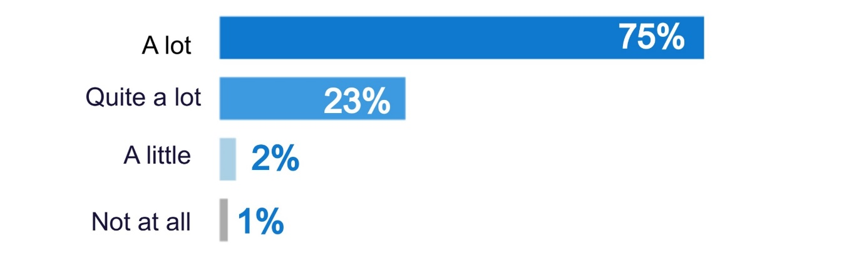

95% felt staff recognise the value of reading for pleasure
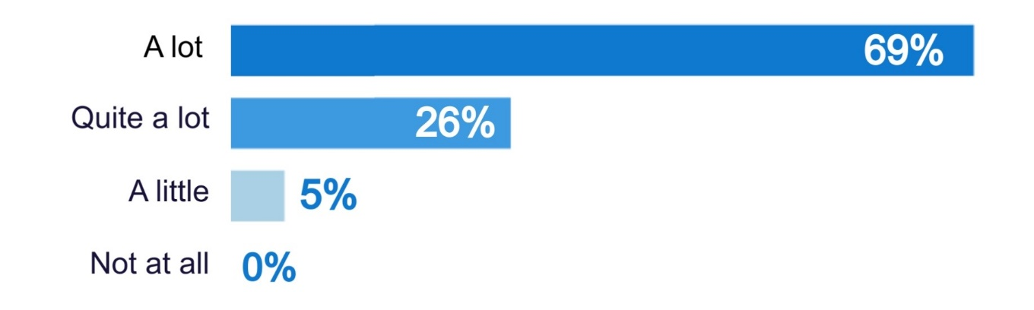

94% felt staff use reading for pleasure with pupils
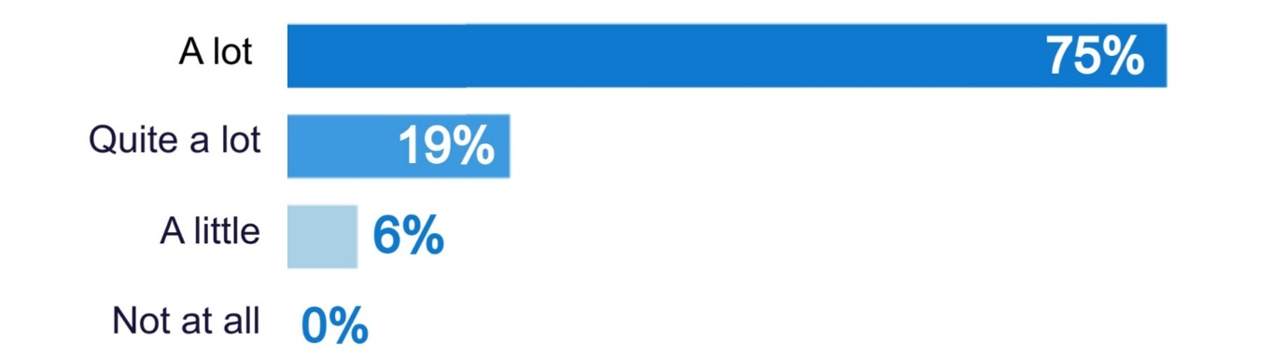

88% felt school staff read aloud to class/ assemblies
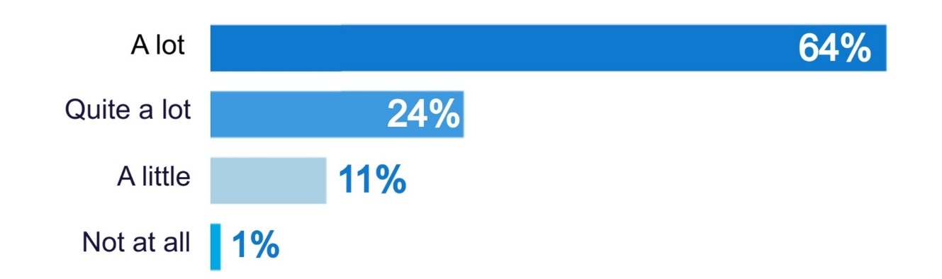

92% felt school staff show pupils that they are readers
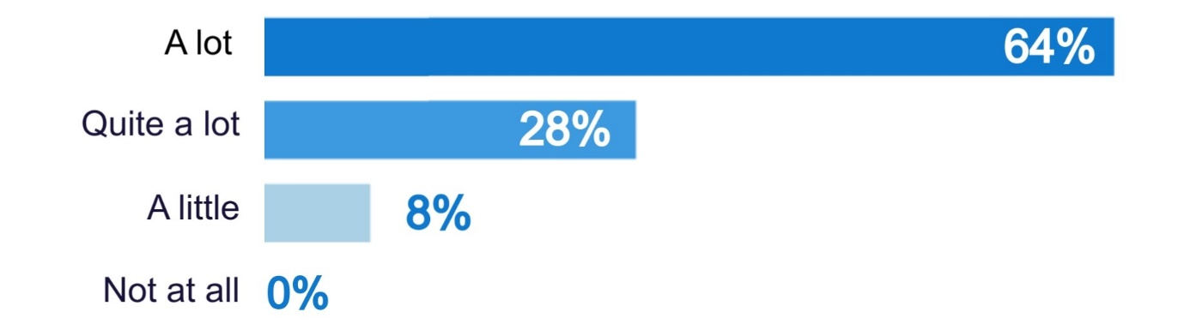

Survey respondents felt that they benefitted from having a Reading Leadership Group, and that Reading Schools had contributed to professional development for staff. Survey respondents also felt that because of Reading Schools there were safe and comfortable places for reading in their school.

Most survey respondents said that Reading Schools had engaged staff across the school (85%). A few (5%) said it had not, and the remainder were not sure. In discussion, schools felt that staff had greatly benefited from taking part in Reading Schools, building connections between staff teams, building relationships with pupils and building staff confidence talking about reading.

“
I think it’s been good for their (staff) relationships with the pupils. It’s given them something else to talk about, and also with other teachers too who they maybe wouldn’t normally talk to.” Teacher, secondary

“
It’s created a consistency and shared language across the school and that in itself helps pupils as it’s predictable. It creates a calmness in the curriculum and across learning approaches which has a huge impact on wellbeing.” Headteacher, primary
Example: connections within the school
One secondary school found that Reading Schools helped to build ownership of literacy and reading across the school. Reading Schools was driven by a team with people from each faculty in the school, the librarian, support workers, pupils and parents. A key change has been the realisation that literacy and reading apply across all subjects.
“The big shift for us is realising that if you’re a chemistry teacher it’s still your role to develop pupils’ literacy. They now see themselves as role models and ambassadors for reading. So for example we’re communicating key words in advance and that means they can be pre-teaching them in their subjects... So things like now they know how to check the literacy levels of a piece of reading they’re giving out in class.” ASN teacher, secondary school

Most survey respondents said that Reading Schools had an impact more widely on families and communities (75%). A very small proportion (1%) said it had not, and the remainder were unsure. Schools said that Reading Schools had resulted in more conversations with parents about reading, and:

- increased understanding of value of reading for pleasure
- increased family engagement with school – through attending reading activities, celebrations, book cafes and visiting the school library or reading aloud to pupils
- increased library visits outwith school time – through ensuring pupils have library cards and know how to visit the library.

“
Family engagement in our school is far better than ever before as a result of the many reading events now being held in school.” Class teacher, primary

A few schools mentioned that parents had become more confident reading aloud to classes, and were keen to be involved in future activities. One school mentioned that the school librarian had, for the first time, become involved in parents’ nights and talked to parents about reading and the library.

Example: families
One school had support from over 100 parent volunteers to ensure all classes had regular visits to the public library, as part of its Reading Schools activity. The school also organised parent events linked to reading, which engaged a large number of parents. Parent volunteers also read books to all classes during Book Week Scotland and bilingual parents read books during International Mother Language Day.

Some schools indicated that they had introduced citizenship and community focused activity through Reading Schools, involving connecting with other groups in the community including other schools, care homes, nurseries and additional support needs centres.

Example: community
One secondary school set up a community reading programme for S4 pupils. It paired pupil readers with people in a local nursery, a care home and the school’s unit for people with complex needs. This programme encourages reading for pleasure while also supporting contribution towards citizenship awards.

Example: community
One secondary school developed community podcasts, with pupils talking about books. These podcasts are sent out to school partners. Senior secondary pupils also go into primary schools to read with primary pupils, as well as going into residential care homes to read to residents. Pupils were trained by the Living Memory Association.

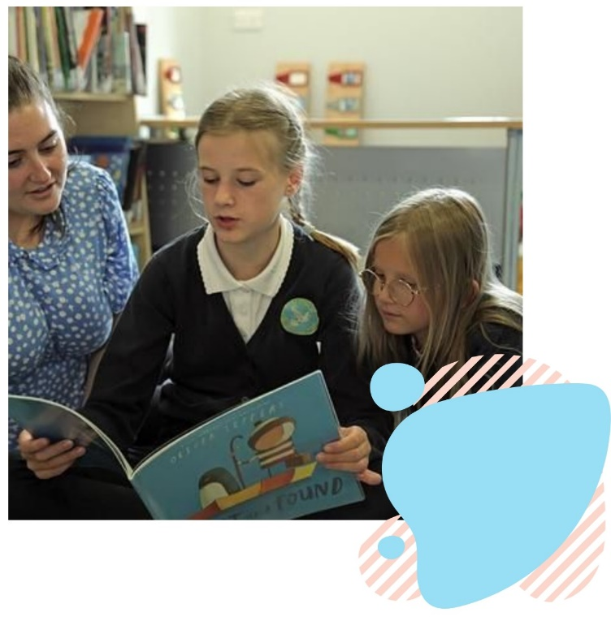

Conclusions

Role of the programme
Schools rated Reading Schools highly and enjoyed taking part. Reading Schools was having an impact on:

- Making reading fun – supporting confident reading choices, pupils identifying as readers, enjoying reading and connecting with others around reading.

- Learning and attainment – supporting wellbeing, creativity, literacy, empathy and resilience.

- Building a whole-school culture – creating an environment where reading is important within the school community, staff recognise the value of reading for pleasure and use reading for pleasure with pupils.

Reading Schools is seen as a high quality, inspiring and exciting accreditation programme for the whole school, which schools enjoy and find valuable.

Key message: Reading Schools is a valuable programme supporting reading, learning, attainment and a culture of reading for pleasure within schools. Reading Schools has a clear ongoing role in building a whole-school approach to reading for pleasure. It may benefit from a softer entry point for schools to introduce more schools to the Reading Schools programme in an accessible and gentle way.

Areas for development – Reading Schools
For Reading Schools, key areas for development over the coming year should include:

- Evidence – reviewing and where possible streamlining evidence requirements and making the process for providing evidence as simple and user friendly as possible.
- Connections – creating and supporting ways for schools to connect with other Reading Schools, sharing views, experiences, ideas and templates.
- All schools – providing ideas and support on how small, rural and/ or secondary schools could achieve their Reading Schools journey – recognising this may look different to others.
- Profile – raising awareness of Reading Schools, the value it brings and its relevance to all schools and their existing work.

Key message: Schools were very positive about Reading Schools and wanted to continue participating. Through learning from early experiences and tweaking evidence processes, the journey could become more user friendly and less resource intensive, while retaining its value. Building connections between schools, ensuring different types of school can achieve a positive Reading Schools journey and wider awareness raising could all help many more schools achieve benefits for their pupils through Reading Schools.

Appendix 1: Examples of activity

Examples of Reading Schools activity
Through this evaluation, schools provided many examples of the activities they developed through Reading Schools. Schools talked about:

- making cosy spaces for reading, increasing access to the school library, increasing links to community libraries
- book swaps, book fairs, book groups
- pupil voice and pupil leadership groups
- 15 minutes reading for pleasure a day – DEAR (drop everything and read) or ERIC (everyone reads in class) time
- paired reading between senior and junior pupils
- exploring cross curricular topics through reading
- visits from authors
- staff learning, professional development.

Some examples of the activities are provided in more detail below.
Example: pupil voice
One primary school got involved in Reading Schools because the pupil voice committee decided this was a priority. Each year, the pupil voice committee chooses the focus of the school. For 22/23 the committee chose to try to become a Reading School.

Example: reading in class
One school talked about how it had incorporated reading into its daily routines.
“Time reading excites everyone every day. After the lunchtime playground dramas, they want to come back in after breaks. They can read independently, in groups, listen to audio books. We prioritise comfy reading in the school, so we have loads of cushions and rugs. Children can lie on a cushion or turn their chair upside down and lean against it to read. Ultimately reading is a pleasure and should be a sociable activity. It’s lovely seeing them reading to each other.” Headteacher, primary

Example: spaces for reading
One primary school created imagination stations around the school, to build spaces for reading for pleasure. They were rooms with tents, fairy lights and bean bags and there were spaces where pupils could lie and read books. These are open at lunchtime and break time every day, and can be used at set times within classes too.

Example: reading aloud
One primary school has guest readers who come in to read to the whole school. This started with different staff reading to the whole school – the janitor, the headteacher, the support staff – and the pupils loved it. They link this across the curriculum too, for example learning about Viking culture.

Example: activities across the school
One school got involved in Reading Schools as part of wider work to increase reading for pleasure. The school had a very small library and pupils associated reading with school work rather than fun. A new library space has been created that the children enjoy being in. The school has introduced a wide range of activities and events including:
- a travelling book fair
- book week including working in pairs to write adventure stories which were bound into A5 booklets for parents
- a reading evening for parents
- a writing morning with pupils and parents
- book buddying with older pupils paired with younger pupils to read and talk about books informally – as well as more formal paired reading
- speed dating book recommendations
- use of Bookzilla
- a classroom Reading Recommendation Tree
- a canine therapet who children read to with a pupil support assistant.
Teachers use a wall grid and dice game to encourage children to talk about what they’re reading, what their opinions are, and how elements such as plot and character are explored in their current reading matter and relate to their own experiences.

Example: health and wellbeing
In one primary school, reading has also become a useful and productive tool for responding to some mood changes or behavioural issues. Drop everything and read (DEAR time) is a daily 15-minute protected period where both children and adults can read for pleasure by themselves. If a pupil is having a bad day, a teacher might suggest some reading time by themselves to reset the situation. Some books also act as prompts for discussion on more difficult themes which may be affecting the children’s lives. Dialogue is always encouraged and children are free to say ‘not today’ or ‘not this book’.

Analysis based on those choosing a lot or quite a lot.
Analysis based on those choosing a lot or quite a lot.
Analysis based on those choosing a lot or quite a lot.
Analysis based on those choosing a lot or quite a lot.
Analysis based on those choosing a lot or quite a lot.
Analysis based on those choosing a lot or quite a lot.

