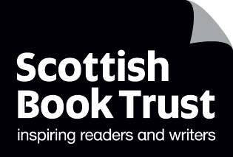

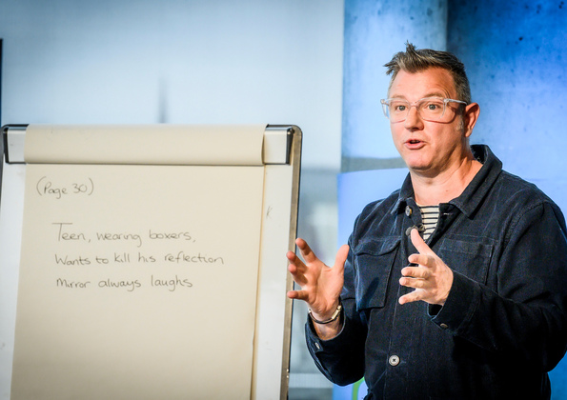

# Brian Conaghan’s teachers as readers guide

Inspiration for your own reading from author and Reading Schools ambassador Brian Conaghan

## Suitable for teachers, librarians and other learning professionals

## Decorative image Resource created by Brian Conaghan

scottishbooktrust.com



Scottish Book Trust is a registered company (SC184248)

and a Scottish charity (SC027669).

## Contents

About this resource 2

The benefits of reading and literacy in schools 3

Does reading improve behaviour? 4

Ideas to get teachers reading 6

Recommended books by interest 7

Science 7

Social studies 8

Arts 10

Mathematics 11

Modern languages 12

Religious and moral education 14

Technology 15

Health and wellbeing 16

Literacy and English 18

Further resources 19

Endnotes 21

## About this resource

Welcome to Brian Conaghan’s guide to teachers as readers! This resource collects advice, top tips and some books recommendations. To really build a sustainable reading culture in your school, it is important that everyone identifies as a reader. It doesn’t stop at class teachers – all staff across the school play a huge part in promoting reading for pleasure.  
  
In this resource, you’ll find:

* The benefits of reading and literacy in schools, including learning across the curriculum, personal development and your school community
* Ideas to help teachers get reading
* Book recommendations for learning professionals based on your interests (please note, these book recommendations are not intended for pupils – for that, you should see our [book lists](https://www.scottishbooktrust.com/book-lists) or [Book Discovery Guide](https://www.scottishbooktrust.com/learning-resources/book-discovery-guide))

Using this resource can support the following key areas:

* [1.2.3 – Staff being seen as readers themselves](https://www.readingschools.scot/resources/visible-staff-role-modelling-across-the-school)
* [1.2.5 – Staff knowledge of contemporary children’s literature](https://www.readingschools.scot/resources/1-2-5-staff-knowledge-of-contemporary-children-s-literature)

Now – over to Brian!

## The benefits of reading and literacy in schools

* Regular reading helps **improve vocabulary**[1]**, comprehension**[2] **and critical thinking skills**[3].
* Reading **fosters better writing abilities** as pupils are exposed to diverse sentence structures and styles[4].
* There is a **strong correlation between reading for pleasure and academic success**[5]. Pupils who read frequently tend to perform better across various subjects, including mathematics[6] and science[7], due to **improved cognitive skills**[8] and a **broader knowledge base**[9].
* Reading diverse books allows pupils to explore different cultures, perspectives, and experiences. This helps **build empathy and understanding**[10], which are crucial for social development and personal growth[11].
* Reading can be a form of escapism and relaxation, **reducing stress and anxiety[12]**. It also helps **develop emotional intelligence** by allowing students to understand and manage their own emotions through the experiences of characters in books[13].
* Engaging with books requires concentration and prolonged attention, which helps students **develop better focus and discipline**. These skills are transferable to other areas of their academic and personal lives[14].
* Encouraging reading in secondary schools instils a **love for lifelong learning**[15]. Students who read regularly are more likely to continue seeking knowledge and **staying curious about the world around them**[16].
* Book discussions and reading groups provide opportunities for students to share their thoughts and opinions, **enhancing their communication and social interaction skills**[17]. It also helps **build a sense of community and belonging** among peers[18].
* Reading can help teenagers and young people **develop their identity** including their beliefs, values, goals and personality[19].

### Does reading improve behaviour?

Answer: Yes.

* **Improved emotional regulation**: Reading helps pupils understand and manage their emotions by proving insights into different characters’ feelings and situations. This understanding can lead to better emotional regulation and less impulsive behaviour[20].
* **Increased empathy and social skills**: Engaging with diverse characters and stories can foster empathy and improve social interactions[21]. Pupils who read regularly are more likely to understands other’s perspectives, leading to more positive behaviour in social settings[22].
* **Enhanced focus and patience**: Reading requires concentration and patience, skills that are transferable to other areas of life including classroom behaviour and task completion[23].
* **Stress reduction**: Reading can be a calming activity that helps reduce stress and anxiety, leading to a more relaxed and positive demeanour in pupils[24].
* **Cognitive and academic engagement:** Pupils who read frequently are often more engaged in academic activities, reducing boredom and disruptive behaviour in the classroom[25].

Overall, the habit of reading contributes to a more disciplined, empathetic, and emotionally stable community which, in turn, enhances overall behaviour in schools.

## Ideas to get teachers reading

* Establishing teacher **book clubs** where educators can read and discuss books together; helping to foster a love and culture for reading and build it into the school community.
* Incorporate reading into **professional development** events, focusing on educational research, pedagogy, and subject-specific literature.
* Organise **reading challenges** with rewards for teachers who meet their reading goals, making it a fun and engaging activity.
* Allocate **dedicated reading times** during the school day or week for teachers (and pupils) to read, perhaps during professional development days.
* Ensure the **school library is well-stocked** with a variety of books and create a welcoming environment for teachers to borrow, suggest and read books.
* Encourage teachers to bring in books they’ve read and enjoyed to **book swap** with colleagues. This will help promote a culture of sharing and reading.
* Arrange for **guest authors** to visit the school and talk about their books, which can inspire teachers to read their work and others.
* Create and share **collaborative reading lists** tailored to different interests and subjects, encouraging teachers to explore new genres and topics (you can use the ones in this resource to get you started!)
* Every month, ask a different department to suggest a book to read – these could feed into your **collaborative reading lists**
* Provide **incentives** such as book vouchers, festival tickets, bookshop author events or in-house and/or public **recognition** for teachers who actively engage in reading and share their insights with colleagues
* School leadership/management team can **model reading behaviour** by openly discussing books they are reading and sharing recommendations, setting a positive example from the top down.

## Recommended books by interest

Please note, these book recommendations are for learning professionals. If you’d like to find suggestions you can share with learners, see our [Book Discovery Guide](https://www.scottishbooktrust.com/learning-resources/book-discovery-guide) and our [book lists](https://www.scottishbooktrust.com/book-lists).

### Science

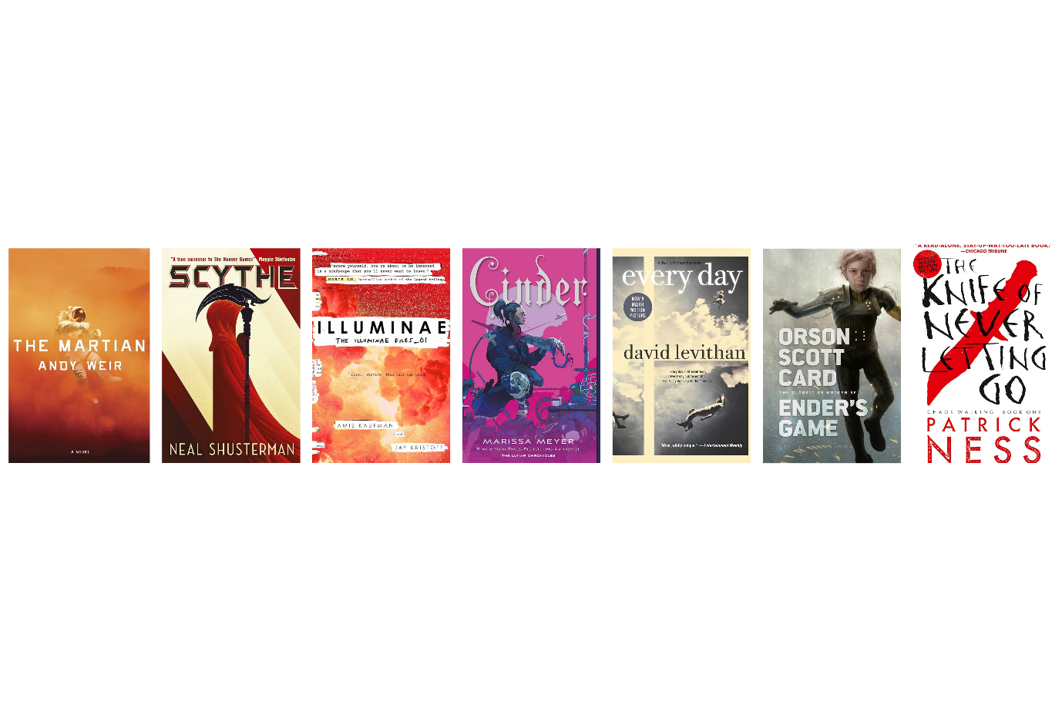

*The Martian* by Andy Weir  
Although technically an adult book, it's highly accessible to YA readers and focuses on an astronaut stranded on Mars, using his scientific knowledge and ingenuity to survive.  
  
*Scythe* by Neal Shusterman  
Set in a future where humanity has conquered death, two teens must learn the art of "gleaning" (killing) to control the population. The book explores ethics and the impact of scientific advancements on society.  
  
*Iluminae* by Annie Kaufan and Jay Kristoff  
This novel, told through a series of documents, follows two teens as they uncover a conspiracy on a space fleet. It integrates technology and scientific concepts in a gripping narrative.  
  
*Cinder* by Marissa MeyerA retelling of Cinderella set in a futuristic world, featuring a cyborg mechanic. The story delves into topics such as biomedical engineering and artificial intelligence.  
  
*Every Day* by David LeviathanThis novel explores identity and consciousness through the story of "A," a person who wakes up in a different body each day. It touches on the psychological and philosophical implications of identity and consciousness.  
  
*Ender’s Game* by Orson Scott CardA classic sci-fi novel about a young boy trained to defend Earth from an alien threat. The book delves into military strategy, psychology, and the ethics of war.  
  
*The Knife of Never Letting Go* by Patrick NessSet in a world where everyone can hear each other's thoughts, this book explores themes of biology, communication, and the impact of technology on society.

### Social studies

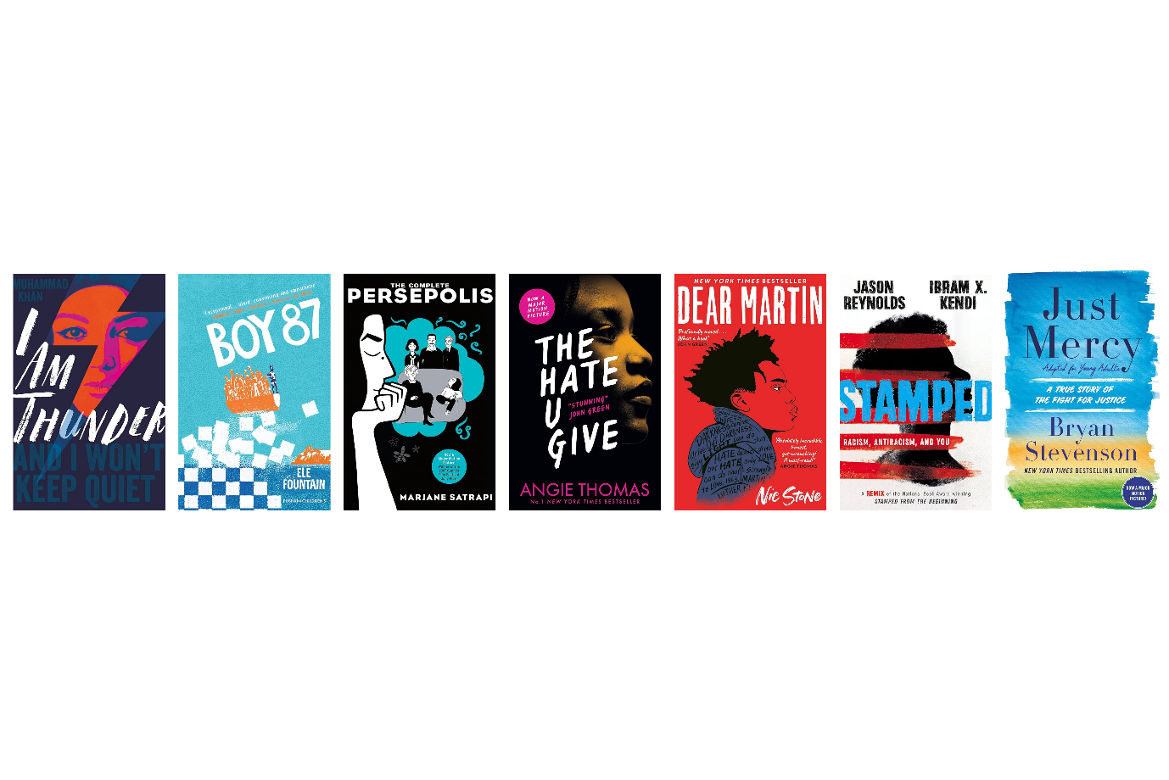

*I Am Thunder* by **Muhammad Khan**This novel deals with radicalization and the pressures faced by young Muslims in the UK. It follows Muzna, a Pakistani teenager who struggles with her identity and the expectations of her conservative parents.

*Boy 87* by **Ele Fountain**This story follows Shif, a boy from an unnamed African country who is forced to flee his home and embark on a dangerous journey as a refugee. The novel addresses themes of migration, survival, and resilience.  
  
*Persepolis* by **Marjane Satrapi**This graphic novel is widely read and relevant for its exploration of the Iranian Revolution and the impact of political upheaval on personal identity. It's an autobiographical account of Satrapi's childhood in Iran and her teenage years in Europe.

#### *The Hate U Give* by Angie Thomas

This powerful novel addresses issues of race, police violence, and social justice. It follows Starr Carter, a teenager who witnesses the police shooting of her unarmed friend and the subsequent fallout.  
  
*Dear Martin* by Nic Stone  
This book explores racial profiling and systemic injustice as it follows Justyce McAllister, an African American high school student who starts a journal to Dr. Martin Luther King Jr. after being wrongfully detained by the police.  
  
*Stamped: Racism, Antiracism, and You* by Jason Reynolds and Ibram X. KendiA remix of Kendi's *Stamped from the Beginning,* this book provides a historical examination of racism and antiracism in America, making it a valuable resource for understanding historical and contemporary social issues.  
  
*Just Mercy (Adapted for Young Adults)* by **Bryan Stevenson**This adaptation of Stevenson's memoir discusses his work as a lawyer defending wrongfully convicted individuals on death row, highlighting issues within the criminal justice system and advocating for social justice and human rights.

### Arts

#### *Ink* by Alice Broadway

This dystopian novel explores a society where people's lives are tattooed on their skin. It's a visually rich narrative that delves into themes of identity and artistic expression through body art.

#### *Artichoke Hearts* by Sita Brahmachari

This coming-of-age story follows 12-year-old Mira as she navigates her grandmother's terminal illness, first love, and the transition from childhood to adolescence. The novel beautifully incorporates themes of art and creative expression as Mira deals with her emotions through drawing and journaling.

***A Sky Painted Gold* by Laura Wood**   
Set in 1920s Cornwall, this novel follows Lou, a young girl who becomes enchanted with the glamorous lives of the Cardew siblings. The book is rich with descriptions of the arts, including literature, fashion, and architecture, making it a great read for those interested in historical and cultural arts.

***Notes on a Nervous Planet* by Matt Haig**   
Though not strictly YA, this book is accessible to young adults and addresses the impact of modern life on mental health. Haig's reflections on social media, consumerism, and self-expression offer valuable insights for students exploring the intersection of the arts and mental health.

***The Black Flamingo* by Dean Atta**   
This powerful verse novel follows Michael, a mixed-race gay teenager, as he discovers his identity and finds a sense of belonging through drag performance. The book celebrates self-expression, poetry, and the transformative power of the arts.  
  
*Music and Malice in Hurricane Town* by Alex BellSet in a magical version of New Orleans, this fantasy novel revolves around a girl named Jude, who can see and communicate with ghosts. The book weaves together elements of music, voodoo, and Southern Gothic art, making it a captivating read for those interested in how art influences culture and storytelling.

### Mathematics

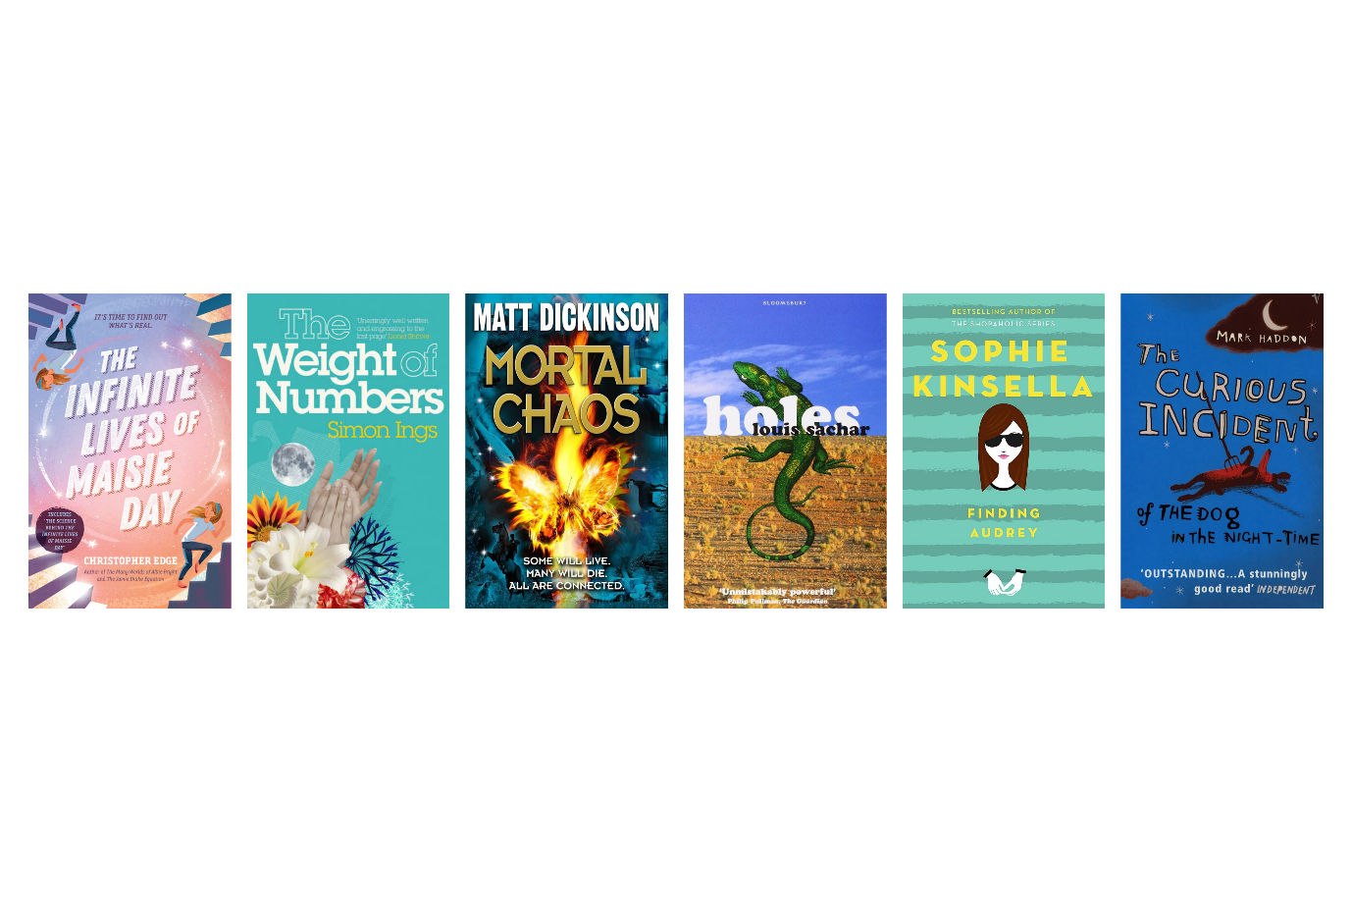

#### *The Infinite Lives of Maisie Day* by Christopher Edge

This novel blends science, math, and a compelling narrative. It follows Maisie, a girl with a deep love for physics and mathematics, as she explores alternate realities and the nature of the universe.

#### *The Weight of Numbers* by Simon Ings

Although this book leans more towards adult fiction, it is accessible to advanced YA readers. It interweaves stories of various characters connected through mathematics, statistics, and the profound impact of numbers on human lives.  
  
*Mortal Chaos* by Matt Dickinson   
This book is about the concept of chaos theory and how small actions can lead to significant and unpredictable outcomes. It’s an exciting way to explore mathematical concepts in the context of a thrilling narrative.  
  
*Holes* by Louis Sachar

This novel incorporates interesting elements of patterns and sequences, making it relevant for discussions about the importance of mathematical thinking in solving problems.

#### *Finding Audrey* by Sophie Kinsella

This book, though primarily about mental health, includes elements of logical thinking and problem-solving as the protagonist, Audrey, works through her anxiety with the help of her family and therapist.

#### *The Curious Incident of the Dog in the Night-Time* by Mark Haddon

This novel is written from the perspective of an autistic 15-year-old boy who has an extraordinary talent for mathematics. It’s a compelling story that highlights the protagonist’s unique way of thinking and approaching problems mathematically.

### Modern languages

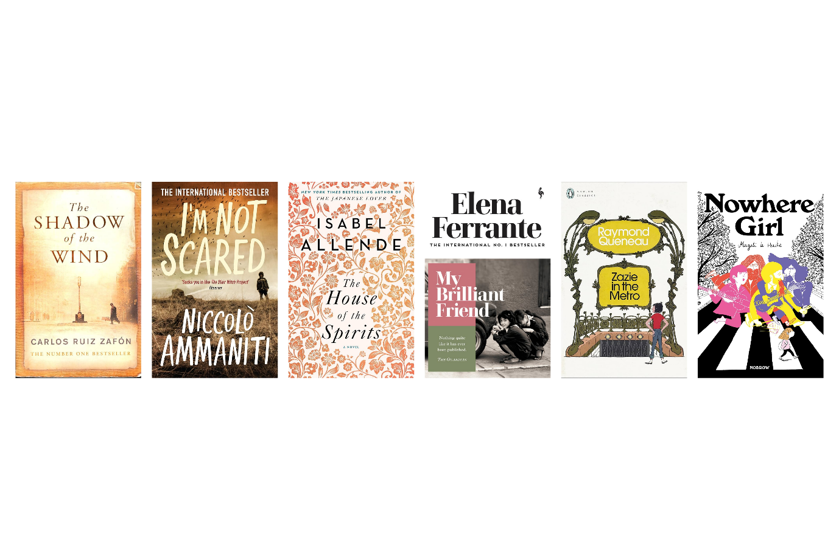

#### *The Shadow of the Wind* by Carlos Ruiz Zafón (translated by Lucia Graves)

Originally written in Spanish, this novel is set in post-World War II Barcelona and follows a young boy, Daniel, who discovers a mysterious book. It's a rich exploration of literature, history, and the power of stories.

#### *****I'm Not Scared* by Niccolò Ammaniti (translated by Jonathan Hunt)****

This psychological thriller follows a nine-year-old boy named Michele who discovers a secret that shatters his innocence. Set in a rural Italian village, the novel explores themes of fear, friendship, and betrayal.

#### *****The House of the Spirits* by Isabel Allende (translated by Magda Bogin)****

Originally written in Spanish, this family saga spans several generations and blends magical realism with political history, offering a deep dive into Chilean culture and history.

#### *My Brilliant Friend* by Elena Ferrante

Originally written in Italian, this novel is the first in the Neapolitan Quartet and follows the intense friendship and life experiences of two girls, Elena and Lila, growing up in a poor neighbourhood in Naples. It provides insights into Italian culture and the complexities of human relationships.

#### *Zazie in the Metro* by Raymond Queneau (translated by Barbara Wright)

This classic novel follows a young girl named Zazie who spends a chaotic weekend in Paris. Known for its playful use of language and humour, it’s a great read for exploring modern French literature.

#### *Nowhere Girl* by Magali Bonnal (translated by multiple translators)

This novel follows the story of a girl who feels out of place in her world and embarks on a journey of self-discovery. It's a poignant exploration of identity and belonging.

### Religious and moral education

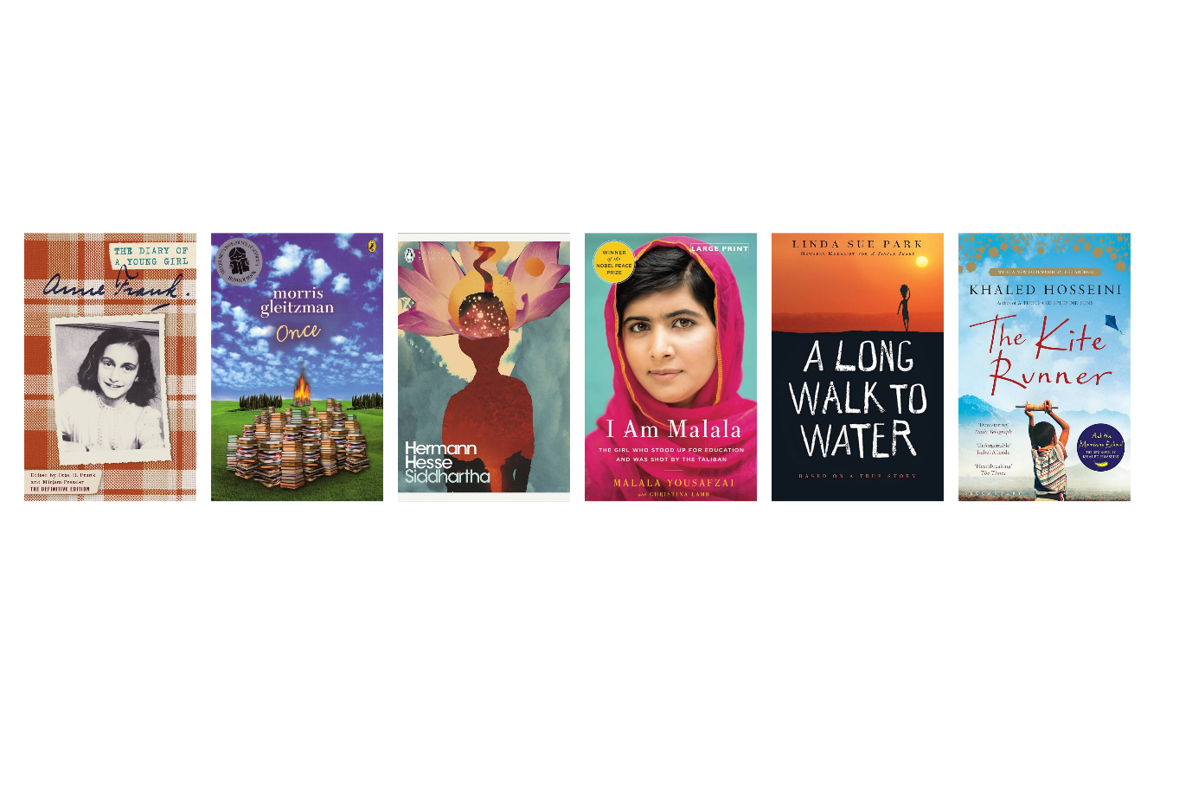

#### *The Diary of a Young Girl* by Anne Frank (translated by B.M. Mooyart)

Originally written in Dutch, this poignant diary of Anne Frank, a Jewish teenager hiding from the Nazis during World War II, explores themes of faith, morality, and human resilience.

#### *Once* by Moriss Gleitzman

A gripping tale set during World War II, told through the eyes of Felix, a young Jewish boy determined to find his parents amid the horrors of Nazi-occupied Poland. Felix embarks on a perilous journey, encountering both the brutality and kindness of strangers. This poignant story is a testament to the resilience of the human spirit and the power of stories to sustain us in the darkest times. Perfect for readers of all ages, Once is a moving exploration of courage, friendship, and survival.

Siddhartha by Hermann Hesse (translated by Hilda Rosner)Originally written in German, this novel follows the spiritual journey of Siddhartha, a young man in ancient India, as he seeks enlightenment. The book explores themes of spirituality, self-discovery, and moral development.

*I Am Malala: The Girl Who Stood Up for Education and Was Shot by the Taliban* by Malala YousafzaiThis memoir, co-written with Christina Lamb, tells the inspiring story of Malala Yousafzai's fight for girls' education in Pakistan. It discusses themes of courage, morality, and the power of faith and education.

#### *A Long Walk to Water* by Linda Sue Park

Based on the true story of Salva Dut, a Sudanese "Lost Boy," this novel alternates between his journey and that of a young girl, Nya, highlighting the struggles for water in Sudan. The story delves into themes of perseverance, moral fortitude, and the importance of community.

#### *The Kite Runner* by Khaled Hosseini

This novel follows the friendship between Amir and Hassan in Afghanistan, exploring themes of guilt, redemption, and the impact of personal and moral choices. While more commonly read by older teens and adults, it's accessible to mature YA readers.

### Technology

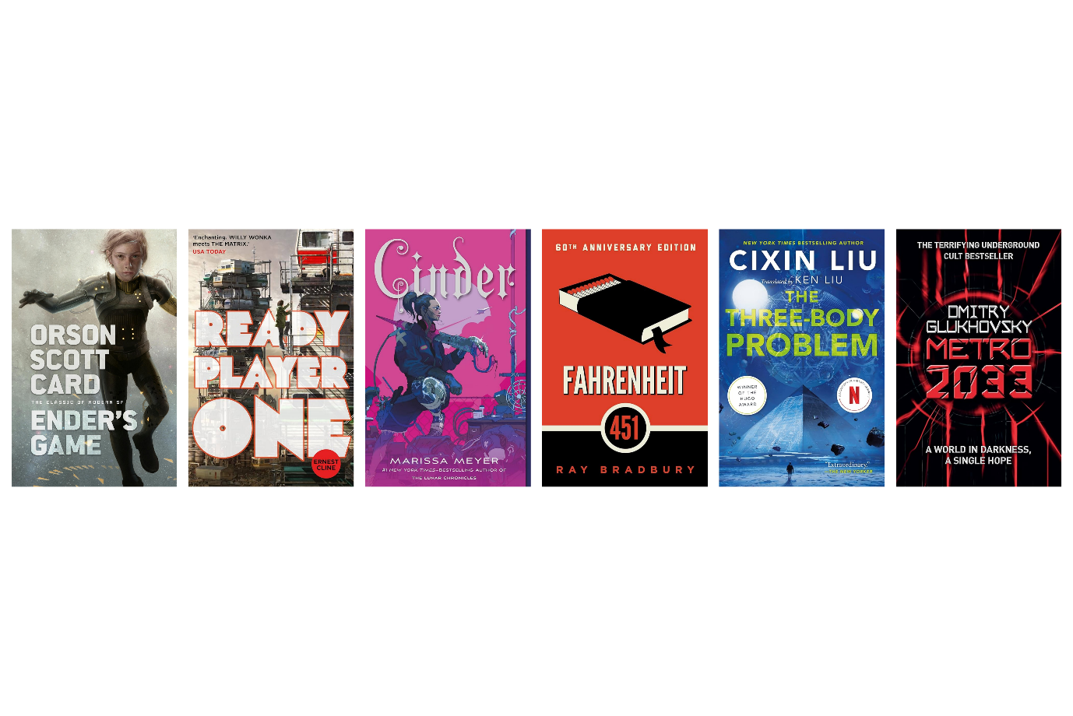

#### *Ender’s Game* by Orson Scott Card

This science fiction novel, while originally written in English, has been widely translated and explores advanced technology, artificial intelligence, and strategic warfare. It follows Ender Wiggin, a young boy trained to lead humanity in a war against alien invaders.

#### *Ready Player One* by Ernest Cline

Another novel originally in English but widely translated, it depicts a future where people escape their harsh realities by living in a virtual reality world called the OASIS. It explores themes of virtual reality, gaming, and the impact of technology on society.

#### *Cinder* by Marissa Meyer

This novel, part of the "Lunar Chronicles" series, is a retelling of Cinderella set in a futuristic world. The protagonist, Cinder, is a cyborg mechanic, and the story explores themes of bioengineering, robotics, and the integration of technology into human life.

***Fahrenheit 451* by Ray Bradbury**Originally written in English, this dystopian novel is widely translated and explores themes of censorship, the impact of technology on society, and the power of knowledge. It tells the story of a future where books are banned and "firemen" burn any that are found.

***The Three-Body Problem* by Liu Cixin (translated by Ken Liu)**Originally written in Chinese, this hard science fiction novel deals with first contact with an alien civilization and explores advanced scientific concepts and the impact of technological advancements on humanity.

***Metro 2033* by Dmitry Glukhovsky (translated by Natasha Randall)**Originally written in Russian, this post-apocalyptic novel is set in the Moscow Metro after a nuclear war. It explores themes of survival, technology, and the human spirit in the face of technological and environmental collapse.

### Health and wellbeing

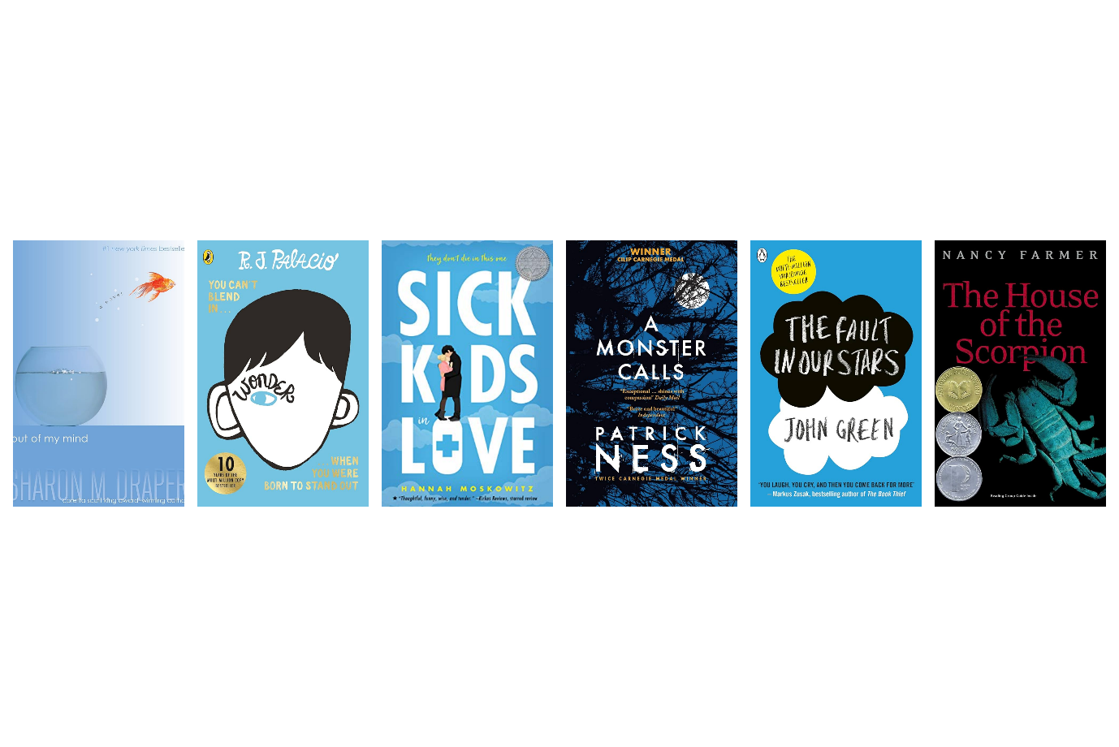

#### *Out of my Mind* by Sharon M. Draper

This novel, originally in English but widely translated, follows Melody, an 11-year-old girl with cerebral palsy who is unable to speak. It explores themes of disability, inclusion, and the power of inner strength.

#### *Wonder* by R.J. Palacio

Also originally written in English, this widely translated novel tells the story of August Pullman, a boy with a facial difference who starts attending a mainstream school. The book addresses themes of kindness, acceptance, and the challenges of living with a physical difference.

***Sick Kids in Love* by Hannah Moskowitz**This novel, originally in English and translated into various languages, is a contemporary romance that deals with chronic illness. It follows the relationship between Isabel and Sasha, two teens dealing with their own health challenges, and explores themes of living with illness and finding connection.

***A Monster Calls* by Patrick Ness**Originally written in English but widely translated, this novel is about a boy named Conor who deals with his mother's terminal illness and his own feelings through visits from a monster. It addresses themes of grief, mental health, and the healing power of storytelling.

***The Fault in Our Stars* by John Green**This novel, originally in English and translated into many languages, follows two teenagers with cancer who fall in love. It deals with themes of illness, mortality, and the impact of serious health conditions on young people.

***The House of the Scorpion* by Nancy Farmer**Although originally in English, this novel has been translated into several languages. It tells the story of Matteo Alacrán, a clone of a powerful drug lord, exploring themes of identity, bioethics, and the psychological impact of being considered less than human.

### Literacy and English

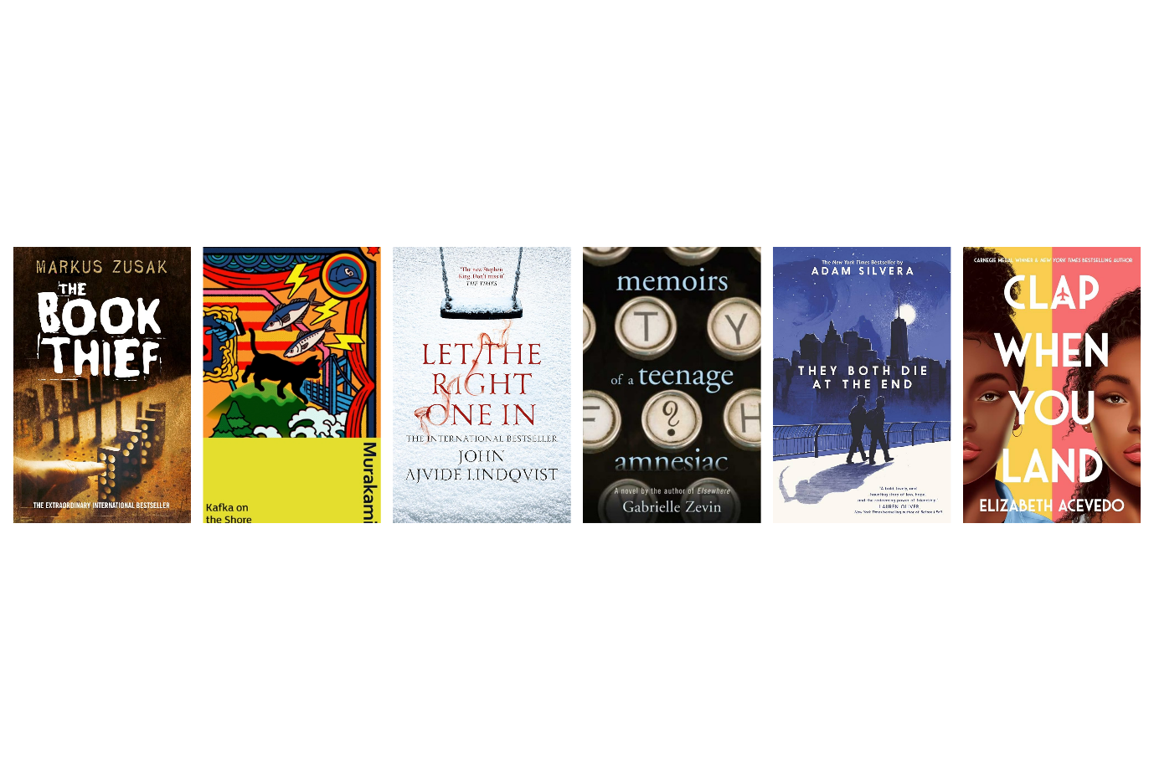

*The Book Thief* by Markus ZusakOriginally written in English by an Australian author, this novel has been translated into many languages. It tells the story of Liesel Meminger, a young girl in Nazi Germany who finds solace in stealing books and sharing them with others. It explores themes of literacy, the power of words, and the impact of war.

*Kafka on the Shore* by Haruki Murakami (translated by Philip Gabriel)Originally written in Japanese, this novel follows the intertwining stories of a 15-year-old runaway named Kafka and an elderly man named Nakata. It explores complex themes such as identity, memory, and fate.

*Let the Right One In* by John Ajvide Lindqvist (translated by Ebba Segerberg)Originally written in Swedish, this novel is a unique take on the vampire genre, focusing on a young boy named Oskar who befriends a mysterious new neighbour, Eli. The story delves into themes of friendship, loneliness, and the supernatural.

*Memoirs of a Teenage Amnesiac* by Gabrielle ZevinAlthough originally written in English, this novel is popular in Japan and has been translated into Japanese. It follows the story of Naomi, a girl who loses her memory and must rediscover who she is. It explores themes of identity, memory, and the journey of self-discovery.

*They Both Die at the End* by Adam SilveraOriginally written in English but translated into several languages, this novel is set in a world where people receive a notification on the day they will die. It follows two boys, Mateo and Rufus, who meet on their last day. It explores themes of mortality, love, and living life to the fullest.

*Clap When You Land* by **Elizabeth Acevedo**Originally written in English by an Afro-Dominican author and translated into several languages, this novel-in-verse follows two sisters, Camino and Yahaira, who learn about each other after their father's death. It addresses themes of family, grief, and the complexities of relationships.

## Further resources

We hope you enjoyed Brian’s insight! Before you go, here’s some further resources you might find useful if you need more inspiration.

### More on the importance of reading for pleasure

* Key area: [2.2.1 Regular opportunities to read for pleasure](https://www.readingschools.scot/resources/regular-opportunities-to-read-for-pleasure)
* Case study: [Regular opportunities tor read for pleasure at Whinhill primary school](https://www.readingschools.scot/articles/regular-opportunities-to-read-for-pleasure-at-whinhill-primary-school)
* Article: [What stops teens reading books for pleasure?](https://www.scottishbooktrust.com/articles/what-stops-teens-reading-books-for-pleasure)
* Article: [Motivating teenagers to read – how you can encourage reading for pleasure at school](https://www.scottishbooktrust.com/articles/motivating-teenagers-to-read-how-to-encourage-reading-for-pleasure-at-school)
* Article: [How reading for pleasure can tackle poverty](https://www.scottishbooktrust.com/articles/how-reading-for-pleasure-can-tackle-poverty)

### More ideas to inspire your own reading

* Key area: [1.2.3 – Staff being seen as readers themselves](https://www.readingschools.scot/resources/visible-staff-role-modelling-across-the-school)
* Key area: [1.2.5 – Staff knowledge of contemporary children’s literature](https://www.readingschools.scot/resources/1-2-5-staff-knowledge-of-contemporary-children-s-literature)
* Article: [How teachers can put the right book in the right hand](https://www.scottishbooktrust.com/articles/how-teachers-can-put-the-right-book-in-the-right-hand?_gl=1*1wozyoq*_ga*MTI2OTIwNzIyNy4xNjk2ODU3MDE0*_ga_0JFC287D3H*MTcyMDAwMjU3OC41Ni4xLjE3MjAwMDM5MjUuNTcuMC4w)
* Article: [Running a staff book group](https://www.readingschools.scot/resources/staff-book-club)
* Resource: Our [My Life as a Reader PowerPoint](https://www.readingschools.scot/resources/discovering-my-reading-identity-resources) can be used to talk to pupils about your identity as a reader throughout your life
* CLPL sessions: Our Book Discovery sessions run throughout the year and are a great way to find out about exciting texts and connect with other learning professionals. Check out our [CLPL for learning professionals page](https://www.scottishbooktrust.com/learning-and-resources/clpl-for-learning-professionals?_gl=1*wbdk93*_ga*MTI2OTIwNzIyNy4xNjk2ODU3MDE0*_ga_0JFC287D3H*MTcyMDAwMjU3OC41Ni4xLjE3MjAwMDM5MjUuNTcuMC4w) for upcoming sessions.

### More book recommendations

* Our [Book Discovery Guide](https://www.scottishbooktrust.com/learning-resources/book-discovery-guide) gathers children and young adult highlights from Scottish publishers, guest recommendations, themed book lists and our top picks. You can access these as online guides or download them as PowerPoints to go through individually or with your colleagues.
* Our [CLPL for learning professionals](https://www.scottishbooktrust.com/learning-and-resources/clpl-for-learning-professionals) includes Book Discovery sessions where we share our top picks on specific topics, genres or format.
* Our [Book lists](https://www.scottishbooktrust.com/book-lists) can be filtered by age, genre, topic and more!

## Endnotes

1. Sullivan, A., & Brown, M. (2015). Reading for pleasure and progress in vocabulary and mathematics. *British Educational Research Journal, 41(6)*, 971–991. <https://doi.org/10.1002/berj.3180>
2. De Naeghel, J., Hilde Van Keer, M.V., & Rossee, Y. (2012). The relation between elementary students' recreational and academic reading motivation, reading frequency, engagement, and comprehension: A self-determination theory perspective. *Journal of Educational Psychology, 104(4)*, 1006–1021. <https://doi.org/10.1037/a0027800>
3. Harward, S. (2019, August 16). Want to become better at critical thinking? Read books. *College Magazine*. <https://www.collegemagazine.com/want-to-become-better-at-critical-thinking-read-books/>
4. Sénéchal, M., Hill, S., & Malette, M. (2018). Individual differences in grade 4 children’s written compositions: The role of online planning and revising, oral storytelling, and reading for pleasure. *Cognitive Development, 45*, 92–104. <https://doi.org/10.1016/j.cogdev.2017.12.004>
5. Mol, S.E., & Bus, A.G. (2011). To read or not to read: A meta-analysis of print exposure from infancy to early adulthood. *Psychological Bulletin,* *137(2)*, 267–96. <https://doi.org/10.1037/a0021890>
6. Hübner, N., Merrell, C., Cramman, H., Little, J., Bolden, D., & Nagengast, B. (2022). Reading to learn? The co-development of mathematics and reading during primary school. *Child Development, 93*, 1760–1776. <https://doi.org/10.1111/cdev.13817>
7. Whitten, C., Labby, S., & Sullivan, S.L. (2016). The impact of pleasure reading on academic success. *The Journal of Multidisciplinary Graduate Research, 2(4)*, 48–64. <https://www.shsu.edu/academics/education/journal-of-multidisciplinary-graduate-research/documents/2016/WhittenJournalFinal.pdf>
8. Sun, Y.-J., Sahakian, B.J., Langley, C., Yang, A., Jiang, Y., Kang, J., Zhao, X., Li, C., Cheng, W., & Feng, J. (2024). Early-initiated childhood reading for pleasure: Associations with better cognitive performance, mental well-being and brain structure in young adolescence. *Psychological Medicine*, *54*(2), 359–373. <https://doi.org/10.1017/S0033291723001381>
9. Cunningham, A.E., & Stanovich, K.E. (1998). What reading does for the mind. *American Educator, 22(1&2)*, 8–15. <https://www.researchgate.net/publication/237109087_What_reading_does_for_the_mind>
10. Webber, C. (2024, May 22). *Why is reading especially important for teens?* Scottish Book Trust.

    <https://www.scottishbooktrust.com/articles/why-is-reading-especially-important-for-teens>
11. Webber, C., Wilkinson, K., Duncan, L., & McGeown, S. (2022). Connecting with fictional characters: The power of books*. Frontiers for Young Minds. 10, 658925.* <https://doi.org/10.3389/frym.2022.658925>
12. Wilkinson, K., Andries, V., Howarth, D., Bonsall, J., Sabeti, S., & McGeown, S. (2020). Reading during adolescence: Why adolescents choose (or do not choose) books. *Journal of Adolescent and Adult Literacy. 64(2)*, 157 –166. <https://doi.org/10.1002/jaal.1065>   
    
13. Lynch. É. (2024, May 22). *How reading improves your mental health and wellbeing.* Scottish Book Trust. <https://www.scottishbooktrust.com/articles/mental-health-and-the-benefits-of-reading>  
    
14. Mak, H.W., & Fancourt, D. (2020). Longitudinal associations between reading for pleasure and child maladjustment: Results from a propensity score matching analysis. *Social Science & Medicine, 253*, 112971. <https://doi.org/10.1016/j.socscimed.2020.112971>
15. Baker, L., Dreher, M., & Guthrie, J. (2000). *Engaging young readers: Promoting achievement and motivation. Solving problems in the teaching of literacy.* Guilford Press.
16. Quick Reads. (2015). *Reading between the lines: The benefits of reading for pleasure.* <https://www.letterpressproject.co.uk/media/file/The_Benefits_of_Reading_for_Pleasure.pdf>
17. Polleck, J.N. (2010). Using book clubs to enhance social–emotional and academic learning with urban adolescent females of color. *Reading & Writing Quarterly*, 27(1–2), 101–128. <https://doi.org/10.1080/10573569.2011.532717>
18. Petrich, N.R. (2015). Book clubs: Conversations inspiring community. *i.e.: inquiry in education, 7(1).* <https://digitalcommons.nl.edu/ie/vol7/iss1/4>
19. Webber, C. (2024, May 22). *Why is reading especially important for teens?* Scottish Book Trust.

    <https://www.scottishbooktrust.com/articles/why-is-reading-especially-important-for-teens>
20. Fancourt, D., Garnett, C., Spiro, N., West, R., & Müllensiefen, D. (2019). How do artistic creative activities regulate our emotions? Validation of the Emotion Regulation Strategies for Artistic Creative Activities scale (ERS-ACA). *PLoS ONE. 14(2)*, e0211362. <https://doi.org/10.1371/journal.pone.0211362>
21. Webber, C., Wilkinson, K., Duncan, L., & McGeown, S. (2022). Connecting with fictional characters: The power of books*. Frontiers for Young Minds. 10, 658925.* <https://doi.org/10.3389/frym.2022.658925>
22. Webber, C. (2024, May 22). *Why is reading especially important for teens?* Scottish Book Trust.

    <https://www.scottishbooktrust.com/articles/why-is-reading-especially-important-for-teens>
23. Mak, H.W., & Fancourt, D. (2020). Longitudinal associations between reading for pleasure and child maladjustment: Results from a propensity score matching analysis. *Social Science & Medicine, 253*, 112971. <https://doi.org/10.1016/j.socscimed.2020.112971>
24. Lynch. É. (2024, May 22). *How reading improves your mental health and wellbeing.* Scottish Book Trust. <https://www.scottishbooktrust.com/articles/mental-health-and-the-benefits-of-reading>
25. Mendelsohn, A.L., Brockmeyer Cates, C., Weisleder, A., Berkule Johnson, S., Seery, A.M., Canfield, C.F., Huberman, H.S., & Dreyer, B.P. (2018). Reading aloud, play, and social-emotional development. *Pediatrics. 141(5),* e2017339. <https://doi.org/10.1542/peds.2017-3393>