

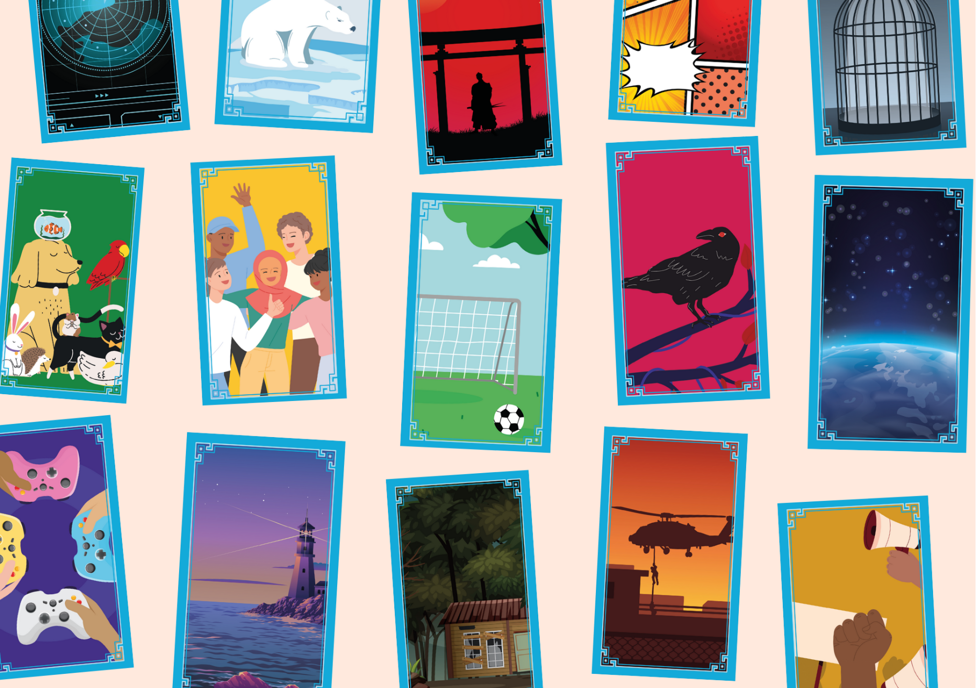

# Story Deck activities

Activities for exploring your Story Deck with young people

## Age: 11-18

## Resource created by Scottish Book Trust

scottishbooktrust.com



Scottish Book Trust is a registered company (SC184248)

and a Scottish charity (SC027669).

## Contents

About this resource 2

Introducing the Story Deck 2

5-10 minute activities 3

15-20 minute activities 4

30+ minute activities 5

Next steps 6

Printable 1: Blank story deck cards 7

Printable 2: Shelf shouters 8

## About this resource

Story Deck is a set of cards that has been developed by [Scottish Book Trust](https://www.scottishbooktrust.com/learning-resources/) to spark structured conversations with young people about the stories they enjoy, including books, TV shows, films, music, video games and more. The goal of this is to help prompt discussion between adults and young people, supporting young people to develop language around their preferences, and the adults to be able to offer tailored recommendations. We have designed these cards to support anyone who works with young people aged 11–18, and they are based on three years of research with young people and librarians about young people and reading for pleasure.   
  
The activities in this pack have been designed to help you introduce and explore the Story Deck with young people, building their confidence in using them to discuss the stories (including books, TV shows, films, music, video games and more) that they enjoy. The activities are ordered by how long they should take to run, and each has an outline of any additional materials you will need.

## Introducing the Story Deck

When using the Story Deck for the first time, it’s important to remember:

* None of the cards have a “correct” meaning, theme or genre. They are all completely open to interpretation. Don’t correct pupils, instead ask them to explain or explore what they see in the cards.
* It’s okay if pupils have strong reactions, including not liking certain cards or talking about stories they haven’t enjoyed. It’s also important that no one feel judged for anything they *do* like.
* Conversation is valuable! Don’t jump straight to trying to find a recommendation – high-quality conversation and exploration is the main purpose of the Story Deck.

## minute activities

### Hot or cold

* 1-6 people
* 1 Story Deck between each group of three

Go through the cards, sorting them into “hot” or “cold” piles according to how you feel about them. If pupils are in groups, they can compare their piles to each other’s.

### Rankings

* 1-6 people
* 1 Story Deck between each group of three

Pull 10 cards. Arrange them by how much you are drawn to them, from least to most. If pupils are in groups, they can discuss this with each other. Which card are you the most or least drawn to? Why?

### Three card summary

* 1-6 people
* 1 Story Deck between each group of three

Pick three cards that represent something you’ve enjoyed recently – it could be a song, an album, a video game, a book, a TV show, a film or a hobby. If pupils are in groups, they can compare who has pulled similar cards and swap recommendations.

## 15-20 minute activities

### Judge by the cover

* 3-12 people
* 1 Story Deck
* A table for laying out books from your library and the Story Deck cards

Pull some books from your library shelves – making sure you include ones that pupils may not be familiar with. Only looking at the cover decide choose three cards that capture what you think the feeling of the book will be. Now, read the blurb – have your card choices change?

### Story Deck Wrapped

* 3-6 people
* 1 Story Deck for each three people
* Pupils have access to their phones or a device

Allow pupils to look at music they have been listening to recently: either on their devices or through Spotify. Ask them to find cards that represent their most played songs. Compare them with other people – are there any crossovers? Do they describe the same artists or songs with different cards?

### Shelf shouters

* 1-12 people
* 1 Story Deck
* Printed Story Deck Shelf Shouter templates

Using a Story Deck Shelf Shouter (see page 8), write a short recommendation for a book you have enjoyed. Pick 1-3 cards you can photocopy to add onto your recommendation, or write their number on.

### Story swap

* 1-12 people
* 1 Story Deck

In groups, ask the pupils to talk about a story they’ve enjoyed recently. There’s only one catch – no spoilers! You can use different cards to describe the plotline, but you can’t *say* what happens.

## 30+ minute activities

### Design a card

* 1-12 people
* 1 Story Deck
* Paper, pens, pencils, crayons, etc.
* (Optional): Collage materials

Discuss in groups – do you think there are any cards or ideas that are missing? Ask the pupils to design any they think would add to the pack – you can use drawing or explore collage. You can use our printable Story Deck template on page 7.

### Share your story

* 1-12 people
* 1 Story Deck for each three people

Ask the pupils to look through the cards and pick one favourite – they can take a photograph of it. Next time you meet, ask them to introduce themselves via the card. What do they see in the card? What drew them to it? They could make:

* a PowerPoint, animation or video
* a playlist of songs that capture the feeling of the card
* a zine, collage or poster (find out how to make a zine [via our website](https://www.scottishbooktrust.com/articles/how-to-make-a-zine)!)

### Create a display

* 1-5 people
* 1 Story Deck for each three people

As a group, choose some cards then look at what it could apply to in your library. You could plan some rotating displays of books using the cards. Think about what information you need on your display to introduce it to any other visitors!

## Next steps

For more information about the Story Deck see our [About Story Deck page](https://www.readingschools.scot/story-deck) on the Reading Schools website, or our [How to use Story Deck page](https://www.readingschools.scot/story-deck/how-to-use) which also includes a PowerPoint you can use to introduce Story Deck to pupils in your school or library. Please note, whilst both of these links are on our Reading Schools website, you do not need a log in to access them.

Also on our website you can find:

* Our full suite of [free learning resources](https://www.scottishbooktrust.com/learning-and-resources/), including our [Creative writing for schools resources](https://www.scottishbooktrust.com/learning-and-resources/creative-writing-for-schools)
* The [Young Writers section of our website](https://www.scottishbooktrust.com/writing-and-authors/young-writers) which gathers opportunities, including competitions and places they can submit their work as well as resources, advice and articles
* Our [book lists](https://www.scottishbooktrust.com/book-lists) and [Book Discovery Guide](https://www.scottishbooktrust.com/learning-resources/book-discovery-guide), which gather our top suggestions of books for young readers

## Printable 1: Blank story deck cards

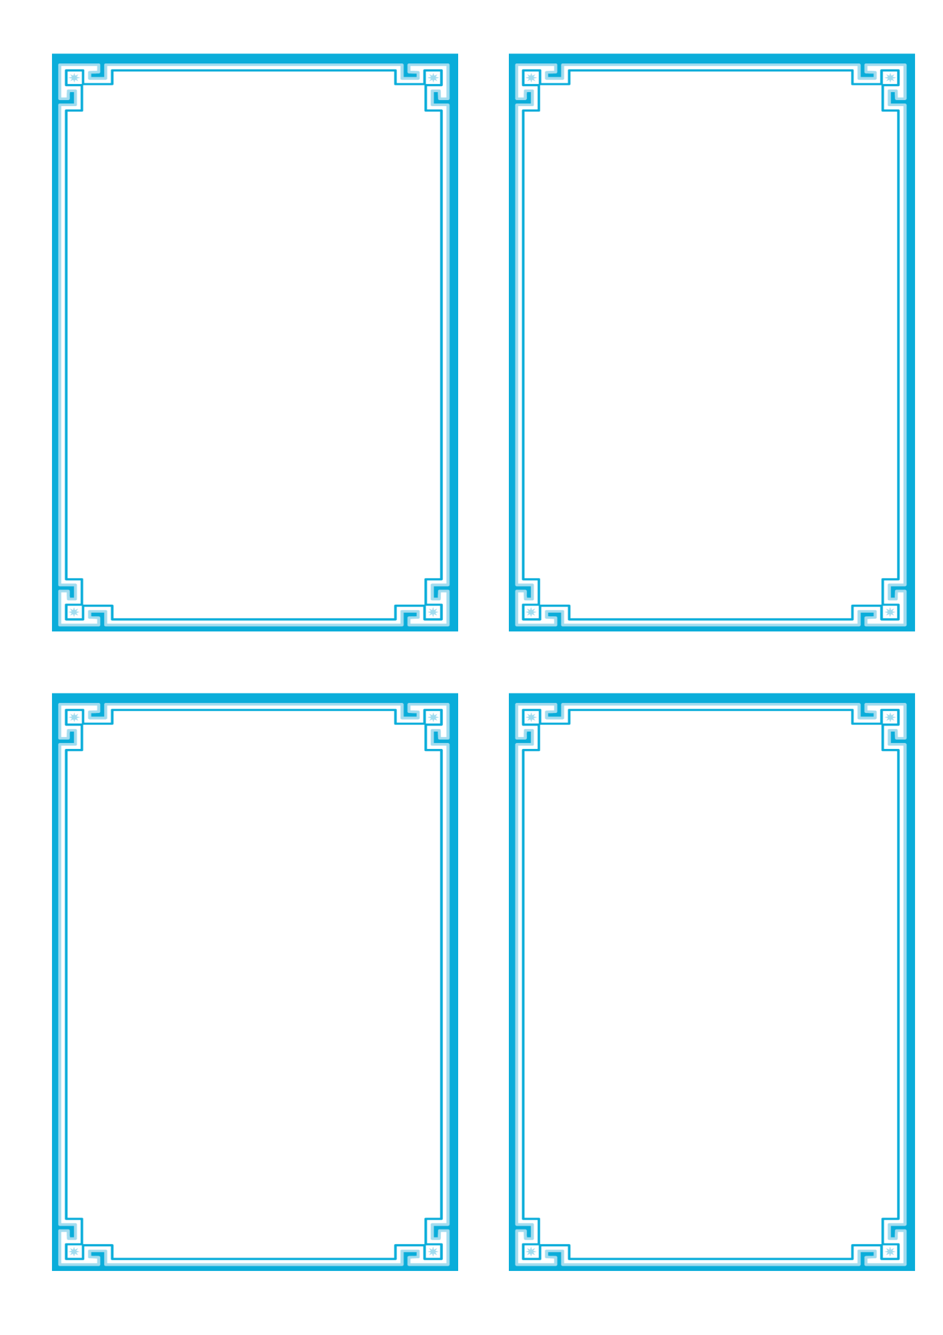Create your own cards with this printable Story Deck template

## Printable 2: Shelf shouters

Create your own shelf shouters! Use the Story Deck image key to either add images of Story Deck cards or their numbers to your book recommendations!

